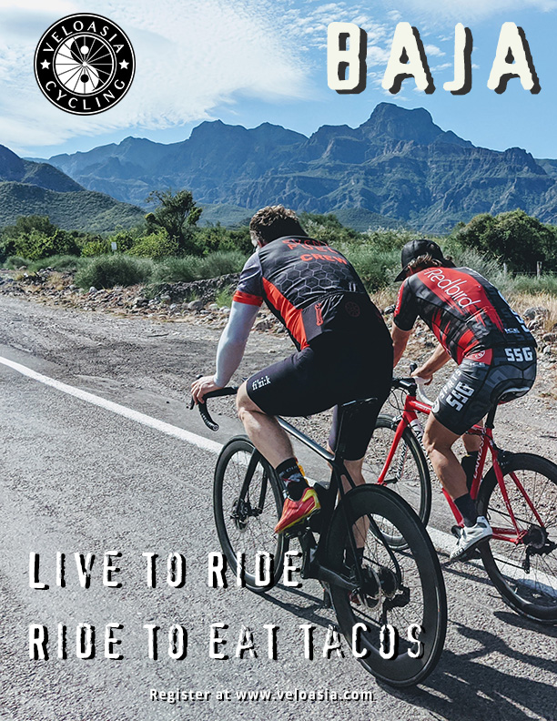

BAJA BY BIKE
Impressions of Baja are often about Cabo resorts, margaritaville cantinas, whale watching and kayaking on the Sea of Cortez… If anything bike-related, it’s usually about bikepacking or the annual Tecate to Ensenada fun bike ride. However, in the last few years Baja has quietly become one of the best road cycling destinations in the world, with miles and miles of newly-paved roads, upscale hotels, sublime landscapes, light traffic, and tranquility away from the violence that plagues other areas of Mexico. Our journey takes in the ever-popular Guadalupe Wine Country, desert nature preserves, and coastal lagoons and marine national parks.
We feel there are three aspects that make a place really standout for bike trips: great cycling, friendly people, and good grub. Baja delivers on all of these, in spades, with a bonus of warm sunny weather and clear skies. We’ll along quiet roads and tranquil countryside. How tranquil? Almost 3/4 of Baja’s 3.3 million residents live near the border cities of Tijuana and Ensenada. The rest of the 55,366-square-mile peninsula—surrounded by the Pacific Ocean on the west coast and the Gulf of California on the east coast—is wide-open space, an increasing amount of which is becoming preserved as federal lands, private reserves, and community projects.
Things are changing quickly in Baja, but for now come ride easy peaceful miles on tranquilo roads in Baja’s rugged beauty of green and verdant landscapes, before the secret gets out.
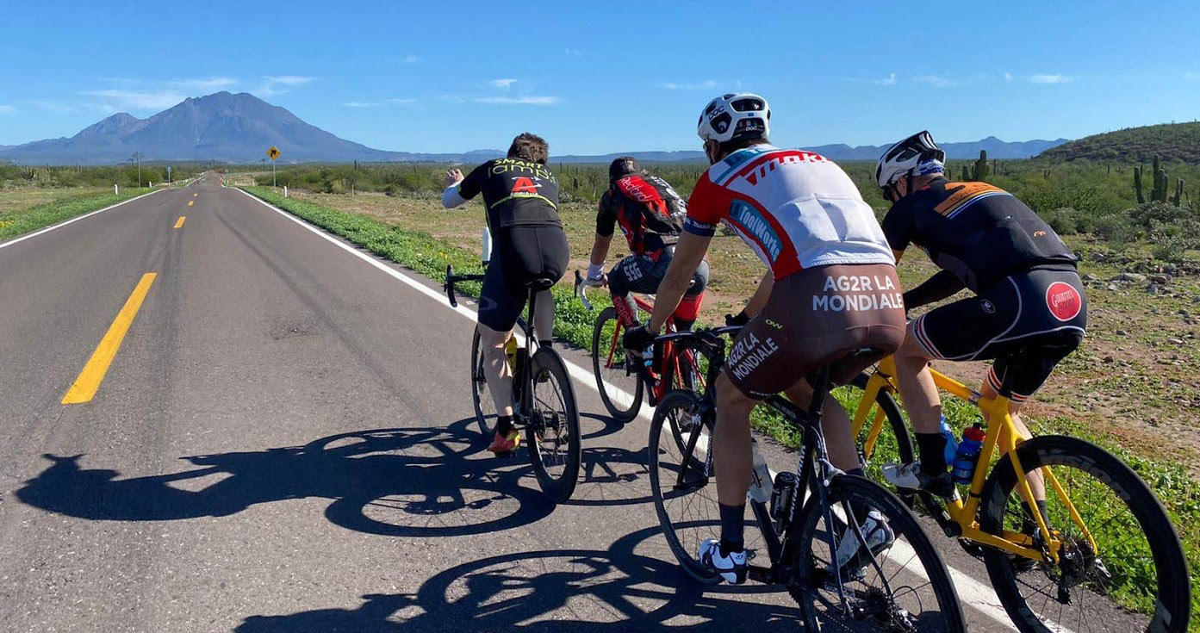
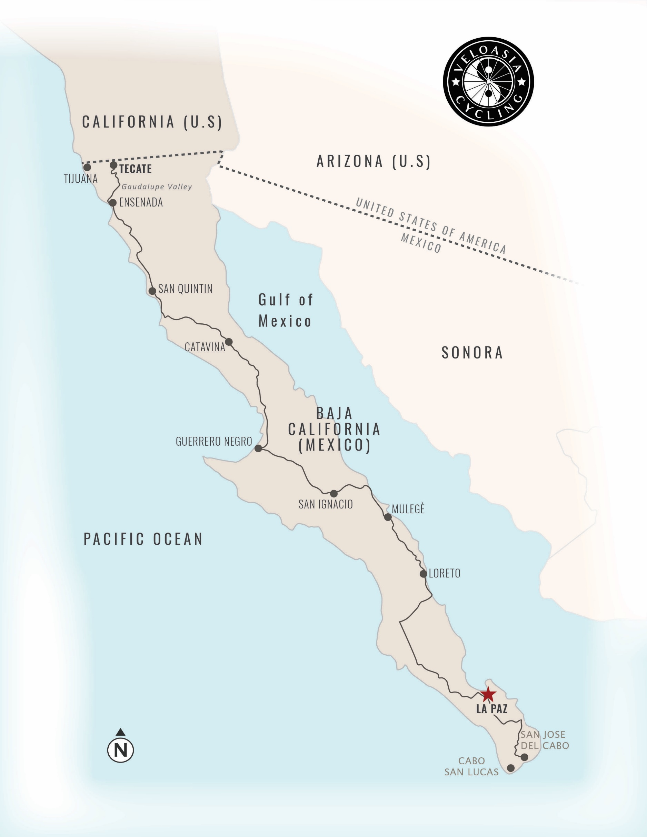

DAY 1: Tecate to Guadalupe 51 MILES +3,227 FEET
RUTA VINO - GUADALUPE WINE COUNTRY
Following the classic Tecate to Ensenada route, but along a new highway with wide shoulders and gentle grades. Our ride meanders through a green countryside, a few small towns, and during the latter part, through the Valle de Guadalupe, Mexico’s fast growing wine region (now over one hundred wineries), which we’ll visit through the afternoon after arrival and lunching in Guadalupe. Our driver, Ivan lives here and leads trips in the valley. After, we’ll enjoy an swim, dinner featuring regional specialties, and overnight in a villa overlooking the valley.
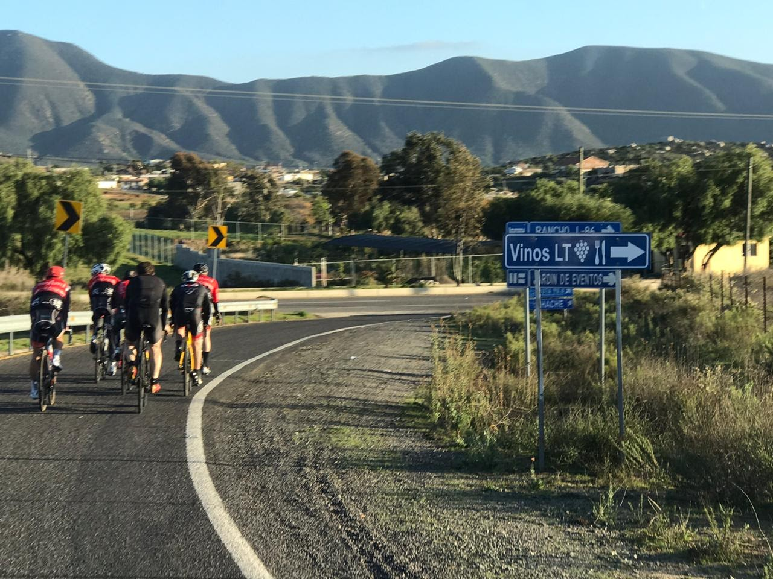
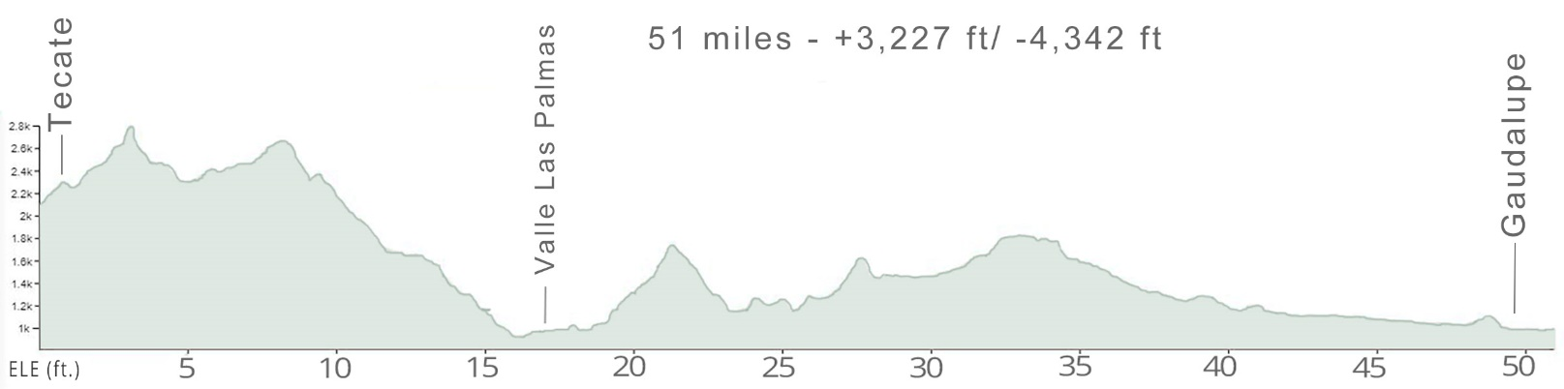

DAY 2: GAUDALUPE to Puenta Colonet 50 MILES +3,114FEET
LAGARS AND GRANJAS
After a delicious breakfast of fresh flour tortillas, local huevos, queso, chilis, frijoles and fruit, we’ll shuttle up the road for our day start in the sienna-colored mountains under expansive skies of Baja, rolling along the green pastures and through green landscapes past small farms. As we crest hills, the landscapes open up and we’ll enjoy breathtaking views over the expansive green valleys. In the afternoon, we reach our secluded beach resort with time to enjoy a walk on the sand before our dinner banquet.
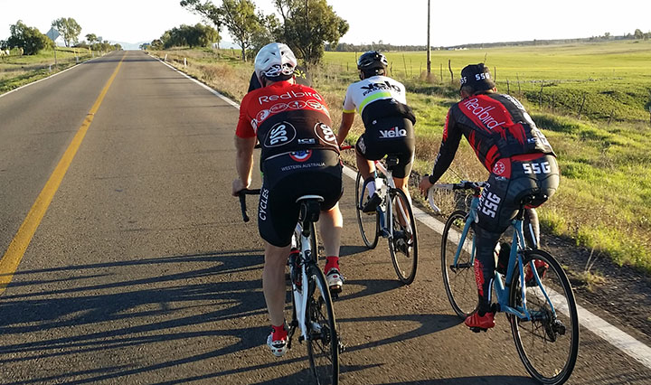

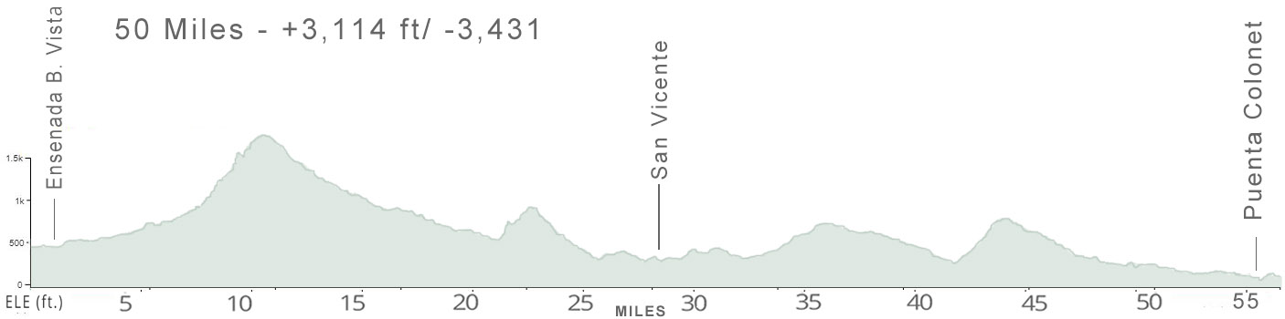

DAY 3: San Quintín to Cataviña 75 MILES +4,234 FEET
Valle de los Cirios
This morning, after the sunrises over the waves, we’ll ride along the coast for a while before climbing into the magnificent and massive Valle de los Cirios nature preserve, with stunning landscapes resembling Joshua Tree, Moab and the Idaho flatirons as far as the eye can see. Along this desolate road without any towns, we’ll marvel at our first glimpse of towering Cardón or Elephant Cactus, the world’s largest cactus, which can reach up to 65 feet high. As we climb up onto the plateau, the sublime landscapes open up in dozens of miles in all directions, the only sounds are light breezes and very little traffic passes this way.
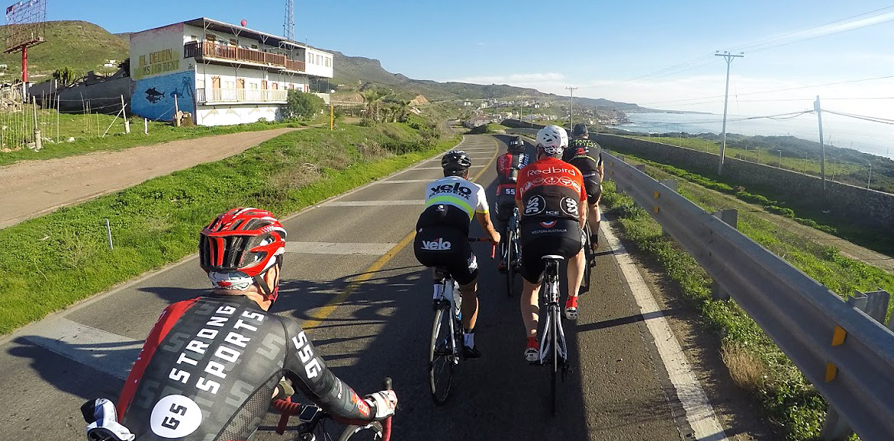
As we reach our destination, a lonely tranquilo outpost situated upon a spring, Cataviña, marked by giant rock boulder formations resembling landscapes in Moab. Today will be our longest ride but there will plenty of cold cervezas waiting by the pool after we arrive.
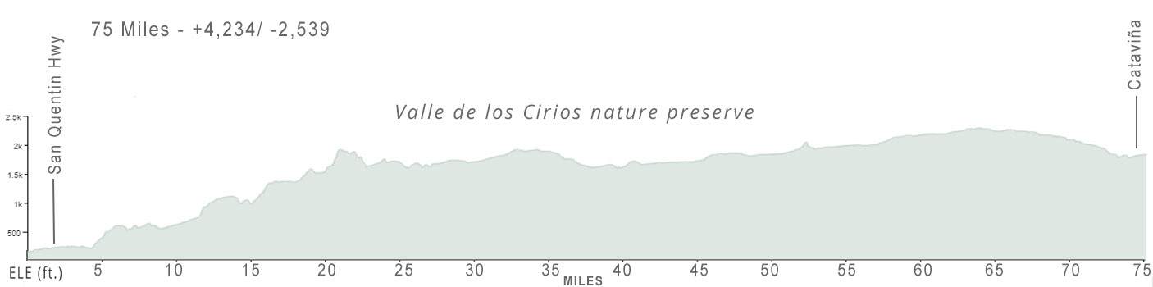

DAY 4: Cataviña TO SAN IGNACIO 68 miLES +1,397 ft
THE CACTUS PLATEAU
If you're awake early, we’ll have a short hike before breakfast watching the sun rise over the boulder plain as the colors change in the morning light. All around our route today is the bed of ancient ocean, now dotted with cactus and other desert plants as far as you can see. This day captures the wonderful solitude of Baja, with only a single town during the flattest ride of our trip over newer pavement.
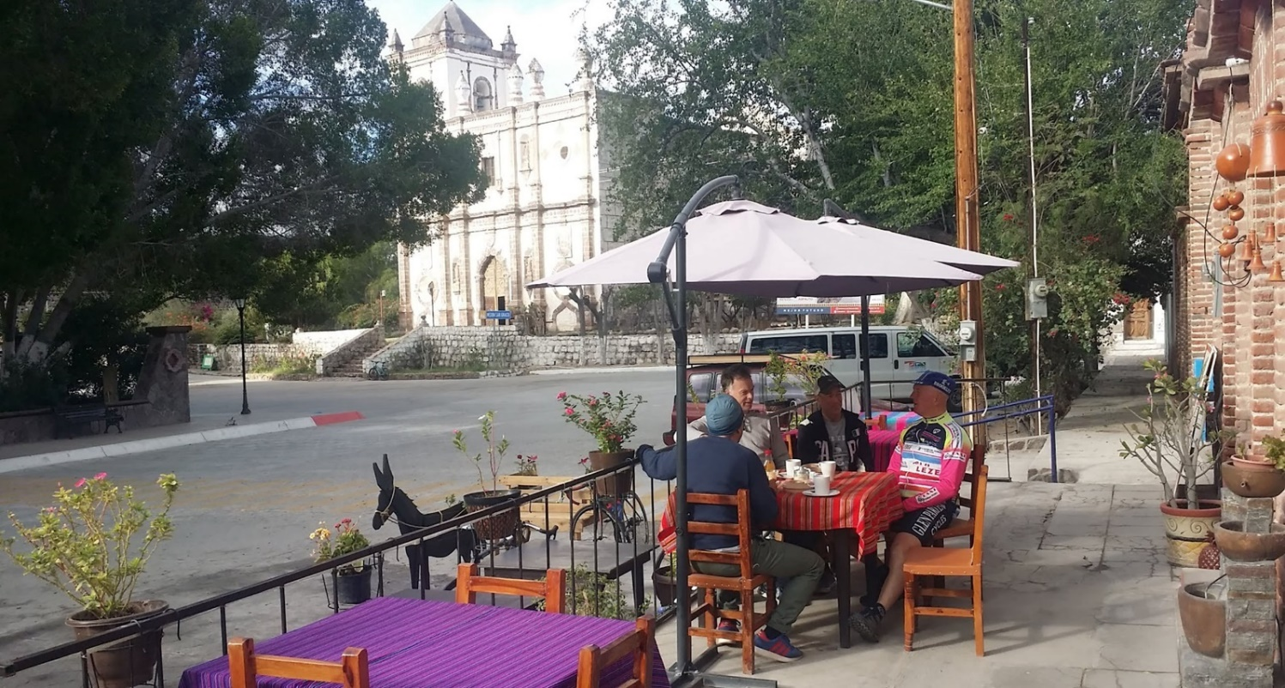
After stopping and loading up, we’ll van to Guerrero Negro for a lunch of delicious fresh local lobster and seafood before moving on to San Ignacio, location of one of the first missions in Baja with a small colonial-era plaza that quant and untouristed.

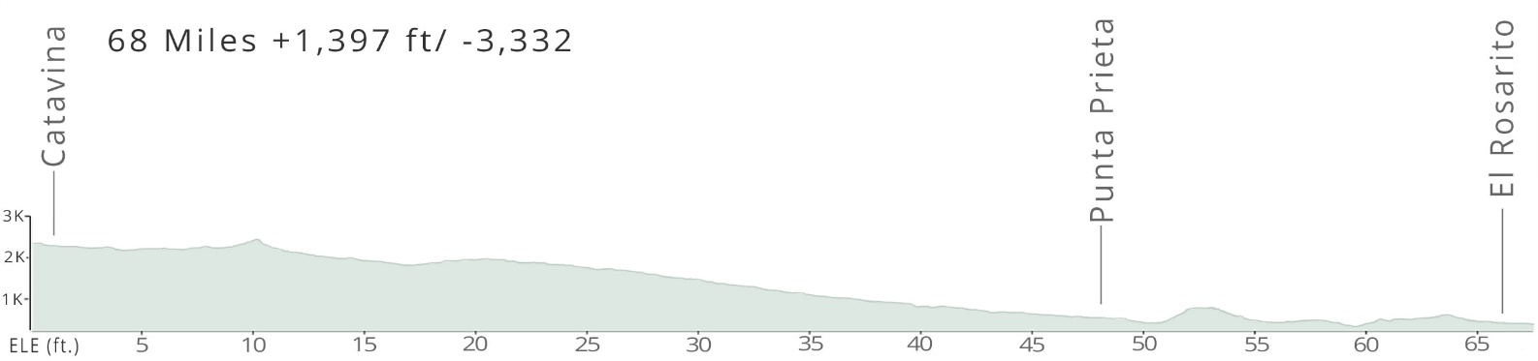

DAY 5: SAN IGNACIO TO Mulegé 46 miLES +2,159 ft
ACROSS THE DIVIDE
Wide colored canyons spread over the landscapes this morning, as we gradually climb a gentle grade of nearly two dozen miles, rewarded after the summit with panoramic views of massive valley of organ pipe and golden barrel cactus we will be dropping down into. After more rustic canyons and smaller ranges, we reach the blue waters of the Sea of Cortez.
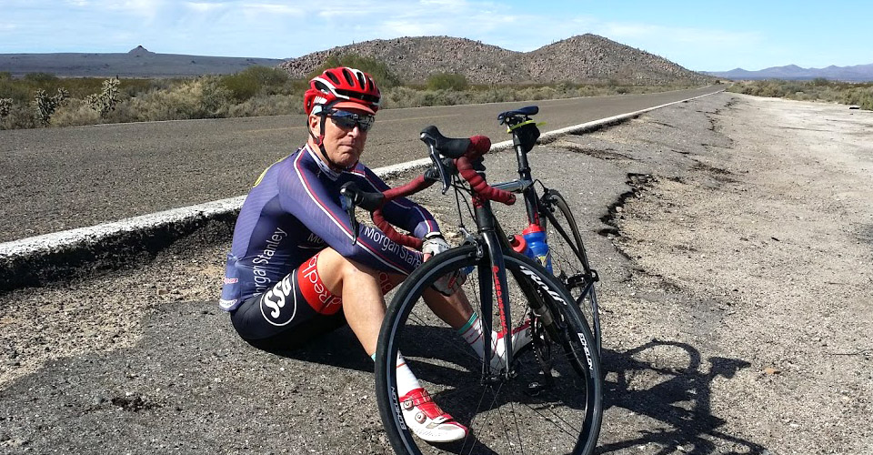
After lunch along the coast, we’ll shuttle to the small oasis town, Mulegé, at the mouth of the Río de Santa Rosalía. Settled by Jesuits in the mid-1700s and was location of the first mission built in Baja. In current years, it has become a bohemian enclave of artists.
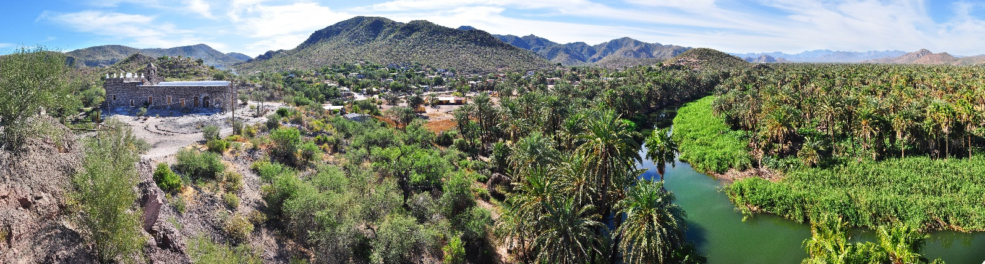
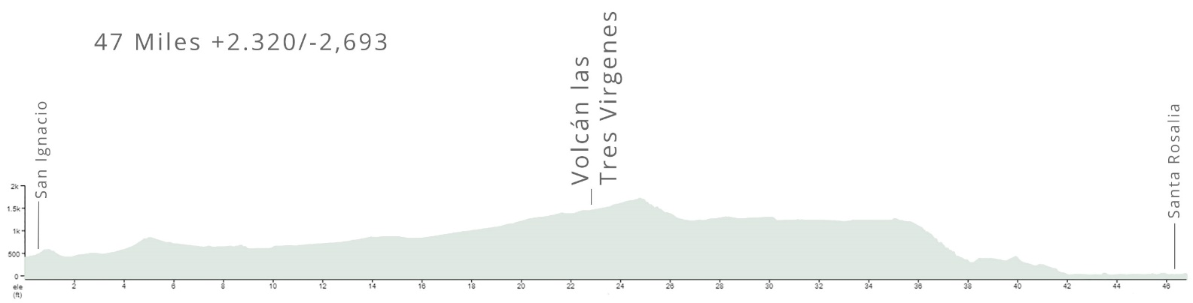

DAY 6: Mulegé to LORETO 84 miLES +2,687 ft
BEACH COVES AND ARROYOS
Today’s ride out of Mulegé, rolling along the coast, is the most spectacular of the trip. We meander along the cliffs along postcard-perfect beach coves and lagoons with bright red cliffs rising dramatically on the inland side. Midway through our ride, we pass through rolling desert plains passing arroyos and pequeño pueblos. At ride’s end, we roll into Loreto, which has just remade it’s pleasant central district. One of our favorite places in Mexico.
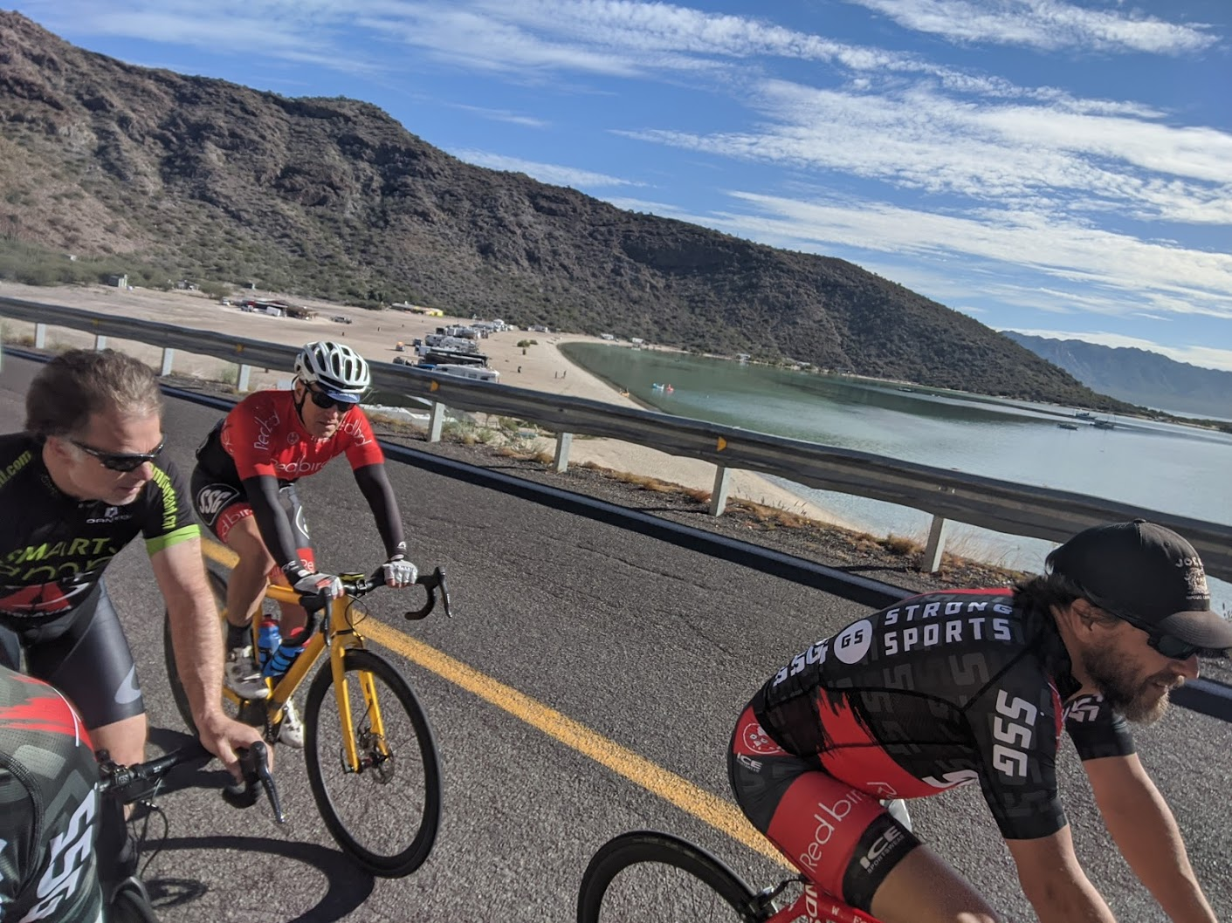
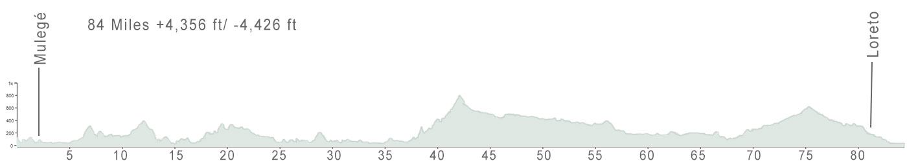

DAY 7: LORETO to LA PAZ 48 miLES +2,205 ft
THE LORETO BAY
After another delicious Mexican breakfast, we’ll ride along the coast with sublime views of the Loreto Bay National Marine Park dotted with islands with a mix of stunning cliffs, wide sandy beaches and rock formations.
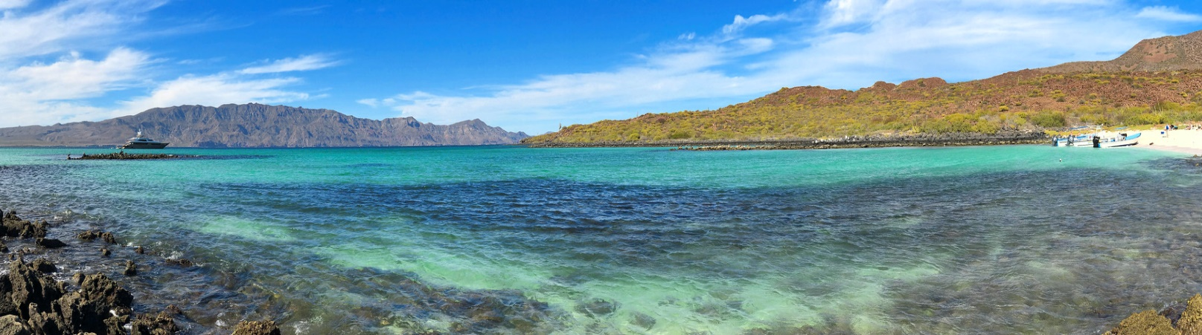
One the longest climbs of our trip appears as we turn inland, but it’s a gentle grade of only two and half miles, followed by stunning canyon landscapes of red and green. In the afternoon, we reach the one of the finest untouristed towns in Mexico, La Paz.
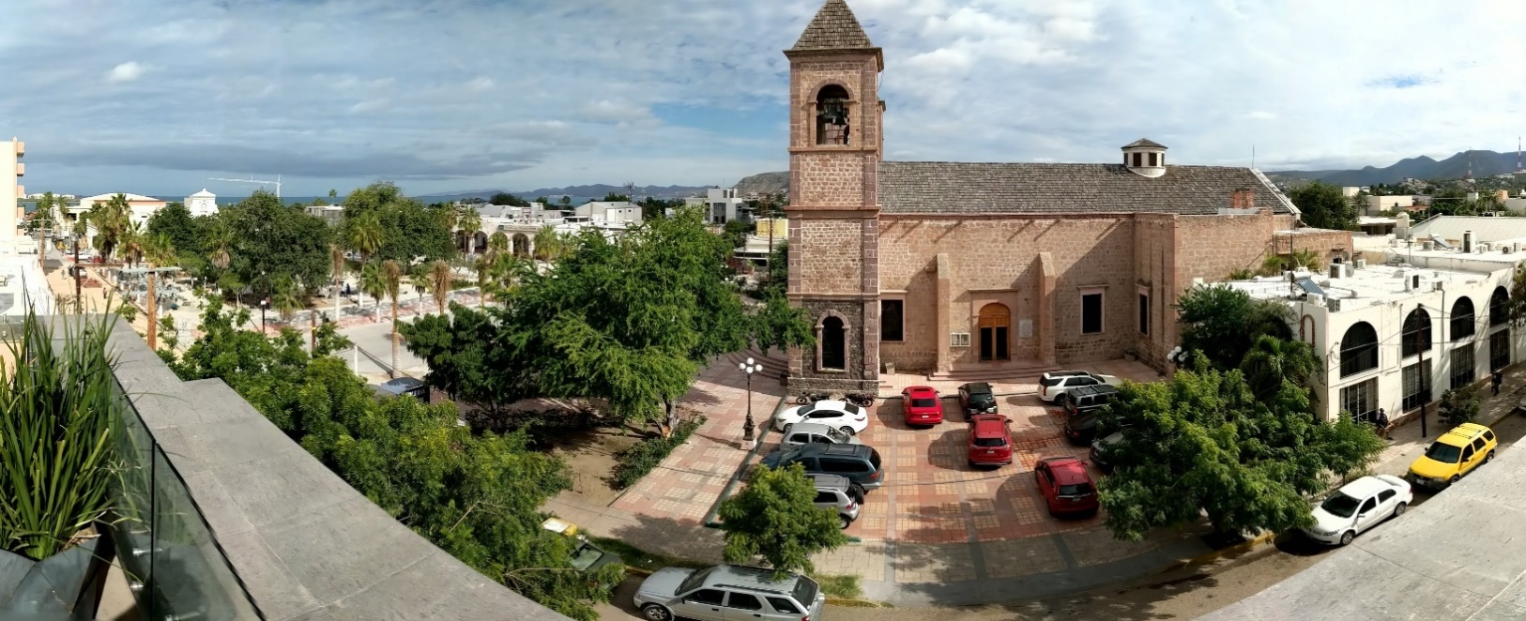

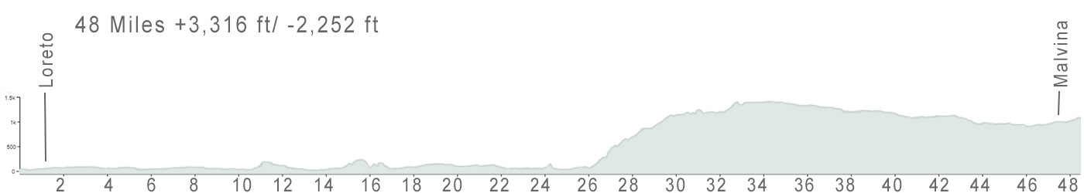

DAY 8: LA PAZ to SAN JOSE DEL CABO 43 miLES +2,999 ft
WILD CANYONS & BLUE WATERS
As the sun rises, enjoy a stroll along the promenade and once last glimpse of the new central plaza. After breakfast we’ll shuttle outside of La Paz and begin our last day of riding through low mountains and scrub hills looping through the countryside. Every hilltop features views of the surrounding canyons and twisting descents heading back towards the Sea of Cortez, where we’ll break in kite-surfing mecca, Los Barriles, to have lunch and pack it in. In the afternoon, we’ll reach San Jose del Cabo, enjoying cold cervezas at the pool to celebrate the end of our journey. Tonight a seafood banquet has been arranged.
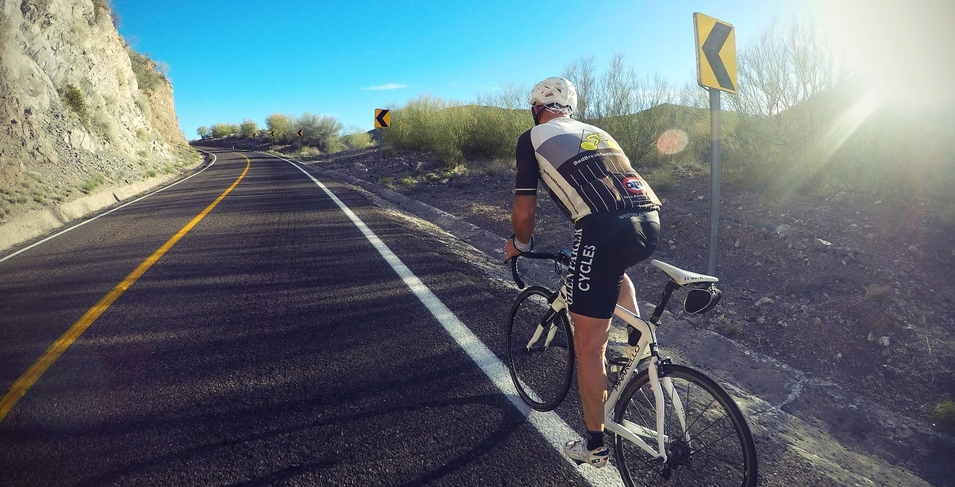
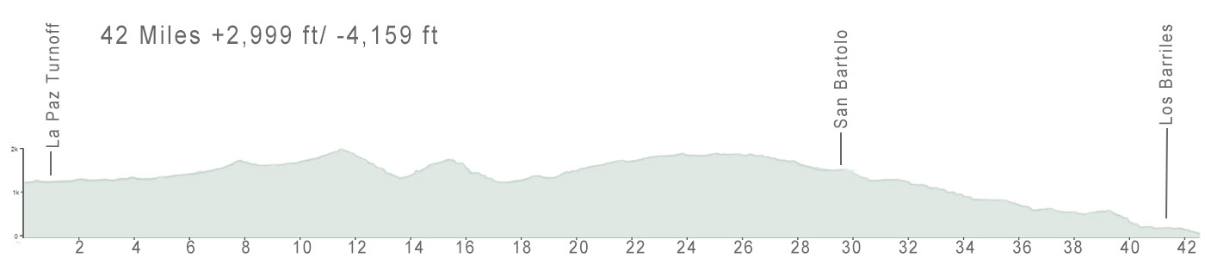

DAY 9: DEPARTURE
HASTA LUEGO
Stay on longer for well-deserved R&R in Cabo, or whale watching, sport fishing, sailing, cooking classes, yoga, wind surfing, snorkeling (Jacques Cousteau famously called the Sea of Cortez, home to some 800 varieties of fish, “the world’s aquarium”), mountain biking, or visiting nearby towns, such as the bohemian enclave Todos Santos.
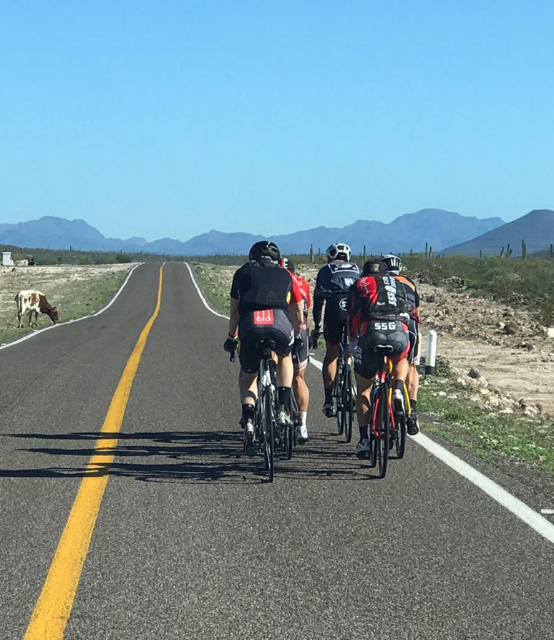

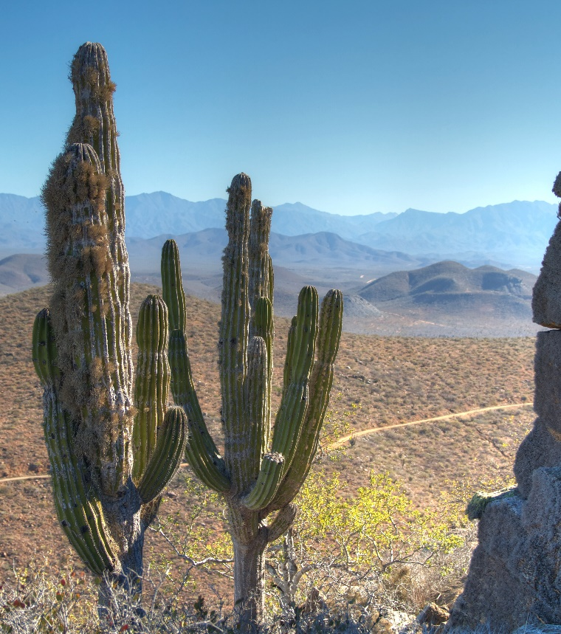 | 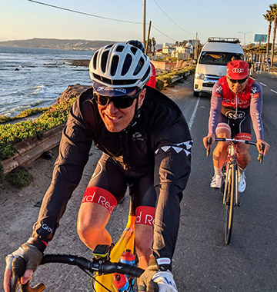
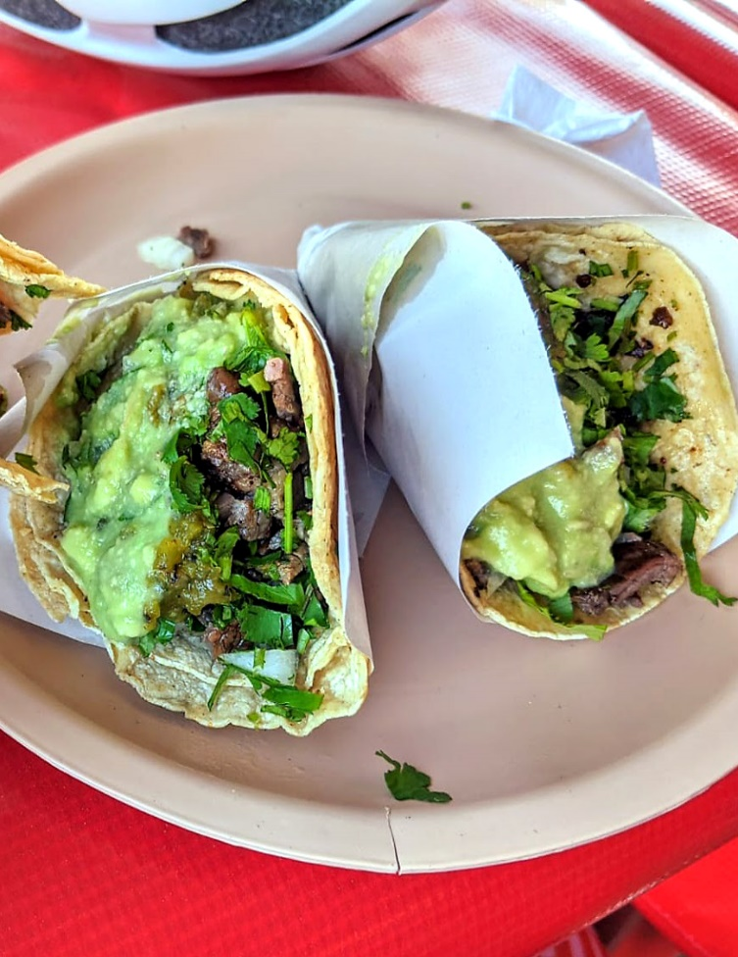 | 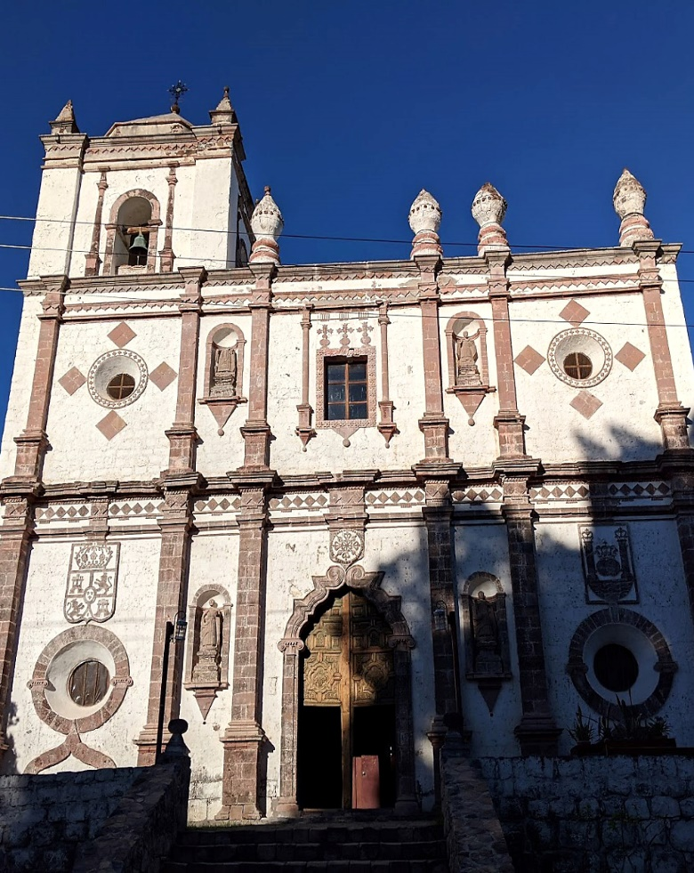

DETAILS
2021 will mark our fourth season of cycling Baja, during which we’ve refined the trip to the best biking routes, places to stay, eating, and training of a world-class support crew with over 20 years’ experience leading trips. This eight-day journey is fully-supported. Riders can expect beautiful, safe rides, plenty of delicious Mexican grub, hot showers, and cultural activities on the side. This 8-day trip is limited to 10 riders. This trip may be organized as a private, custom tour for you and your friends or family. For more information about this trip, please see: www.veloasia.com/baja.html

PRE-DEPARTURE
In addition to a pre-tour preparation packet for Baja, all riders are welcome to contact us in advance of the trip, for questions and information they may need.

ARRIVAL & DEPARTURE
Please contact us before arranging your flights for recommendations, or even booking a ticket. If flying, you’ll want to arrive into San Diego or Tijuana Airports, with departure from Cabo San Lucas.

DAY-TO-DAY
Our Baja trips are designed for moderate to advanced riders comfortable riding 2-5 hours at a steady pace, though all riding is optional -- our Sag wagon is always nearby, even for a catching a quick lift up the longer climbs. We typically ride as a group, though faster riders may ride ahead if desired or add additional mileage. We typically depart mid-morning around 9 AM each day, with a break for lunch. Afternoons after arrival are free, or have schedule sightseeing, such as the Jesuit missions along our route. Mornings before we depart also provides some time to see local sights.

WEATHER
The weather in Baja is sunny and warm, with no rainfall, and typically in the 70s to 80s midday.

HOTELS
In places where there are choices, such as Guadalupe, La Paz and San Jose del Cabo, we stay at the finer properties, while in other places, such as Cataviña, we stay at the only accommodation available, which is rustic yet comfortable. Contact us for specific hotels by location.

DINING
Our past travelers will tell you our trips are as much as about the food as the riding. In fact, after 20 years our Iron Chef Vietnam culinary cycling trip remains our most popular. Our meals feature the best of Baja, from delicious local taco stands, fresh seafood including lobster, grilled and rotisserie meats, heaping bowls of fresh guacamole with warm chips and some of the most delicious tortillas in all Mexico.

EMERGENCY & MEDICAL
For expediency, VeloAsia will arrange medical and evacuation coverage for your participation through a local service who is experienced. The cost of this service is included in your trip cost.

Trip Leaders
Patrick Morris
"Lorem ipsum dolor sit amet, consectetur adipiscing elit, sed do eiusmod tempor incididunt ut labore et dolore magna aliqua. Ut enim ad minim veniam, quis nostrud exercitation ullamco laboris nisi ut aliquip ex ea commodo consequat. Duis aute irure dolor in reprehenderit in voluptate velit esse cillum dolore eu fugiat nulla pariatur. Excepteur sint occaecat cupidatat non proident, sunt in culpa qui officia deserunt mollit anim id est laborum.“

Willard Ford
"Lorem ipsum dolor sit amet, consectetur adipiscing elit, sed do eiusmod tempor incididunt ut labore et dolore magna aliqua. Ut enim ad minim veniam, quis nostrud exercitation ullamco
laboris nisi ut aliquip ex ea commodo consequat. Duis aute irure dolor in reprehenderit in voluptate velit esse cillum dolore eu fugiat nulla pariatur. Excepteur sint occaecat cupidatat non proident, sunt in culpa qui officia deserunt mollit anim id est laborum.”

John Brady
"Lorem ipsum dolor sit amet, consectetur adipiscing elit, sed do eiusmod tempor incididunt ut labore et dolore magna aliqua. Ut enim ad minim veniam, quis nostrud exercitation ullamco laboris nisi ut aliquip ex ea commodo consequat. Duis aute irure dolor in reprehenderit in voluptate velit esse cillum dolore eu fugiat nulla pariatur. Excepteur sint occaecat cupidatat non proident, sunt in culpa qui officia deserunt mollit anim id est laborum. “

Ivan Tolentino
"Lorem ipsum dolor sit amet, consectetur adipiscing elit, sed do eiusmod tempor incididunt ut labore et dolore magna aliqua. Ut enim ad minim veniam, quis nostrud exercitation ullamco laboris nisi ut aliquip ex ea commodo consequat. Duis aute irure dolor in reprehenderit in voluptate velit esse cillum dolore eu fugiat nulla pariatur. Excepteur sint occaecat cupidatat non proident, sunt in culpa qui officia deserunt mollit anim id est laborum. “

TRIP COST
$4,875 for a double room. Single rooms are limited, and are a $1,280 extra cost.
What’s included
- Emergency medical and evacuation insurance
- Pre-trip packet
- All accommodations, all meals, snacks, bottled water
- Technical support and supplies (tools, tubes, tires, cables, etc.)
Not included
- Flight to and from Baja (can be arranged through us)
- Visa (about $20, issued upon arrival)
- Bicycle and gear
- Alcoholic beverage
- Expenses of a personal nature
- Airport transfers (we may assist in arranging)

PRIVATE CUSTOM TRIPS
Most of our trips are private, organized for groups of friends or families. This trip may be organized as a private tour for you and your friends or family, fully-customized to your group’s preferences, including balance of cycling and off-bike activities and sightseeing, even for non-cyclists who want to accompany the trip yet still be engaged with Baja’s sights, attractions, and people. Contact us for more details about arranging a private custom trip to Baja for your group. Note: hotels are limited and can fill for whale-watching high-season up to a year in advance.

ABOUT
Since 1993, VeloAsia has organized bike tours to the most adventurous cycling destinations in the world, including Vietnam, Laos, Cambodia, Turkey, Myanmar, Sumatra, Albania, Bhutan, Chiapas, China, and more. See more about this and other trips at www.veloasia.com.

NEXT STEPS?
If you are ready to sign up, or if you have questions about this trip, other trips, or VeloAsia
in general, give us a call at (415) 680-3788 between 8:00 a.m. to 5:00 p.m. (Pacific Time).
To secure your spot on this trip, please an non-refundable deposit of $1,000 per person. Once we receive your deposit, we’ll contact you about arrival and departure information and other details, and send you a pre-trip packet to you containing detailed information about the Baja trip. This trip may also be arranged as a private, custom tour for you and your friends or family. Register for this trip at veloasia.com

