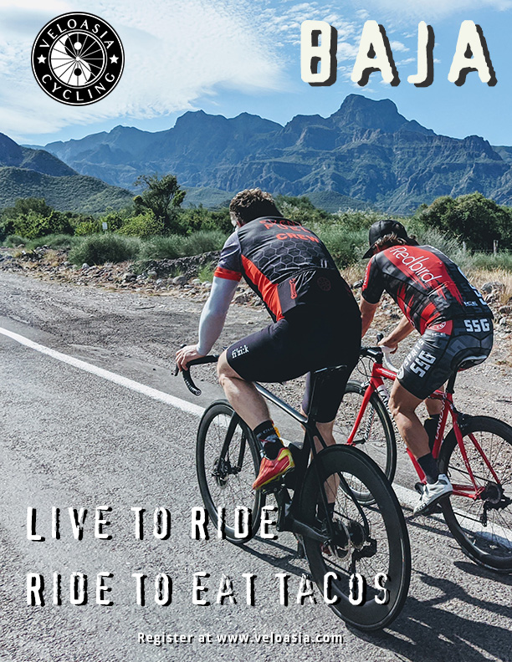

BUENOS DIAS
Our Baja trips began only recently, with past clients from our Asia trips and a few old friends. It was arranged with a clear message there should be few expectations as we’d been many times before for races or fun rides, but never south of Ensenada. Our impressions of Baja “sur” – the south - were mostly of touristy Cabo resorts, margaritaville cantinas, whale watching on the Sea of Cortez, and any cycling was of the “bikepacking” variety – off road in tents to avoid the awful roads.
Instead, we were surprised to be thrilled like we had in early trips to far-flung places like Vietnam and Myanmar -- places not known for cycling, but that had quietly become amazing places to ride. Baja has recently become into one of these places, offering hundreds of miles of newly-paved roads, upscale hotels, sublime landscapes, with little traffic, offering tranquility on the road less traveled.
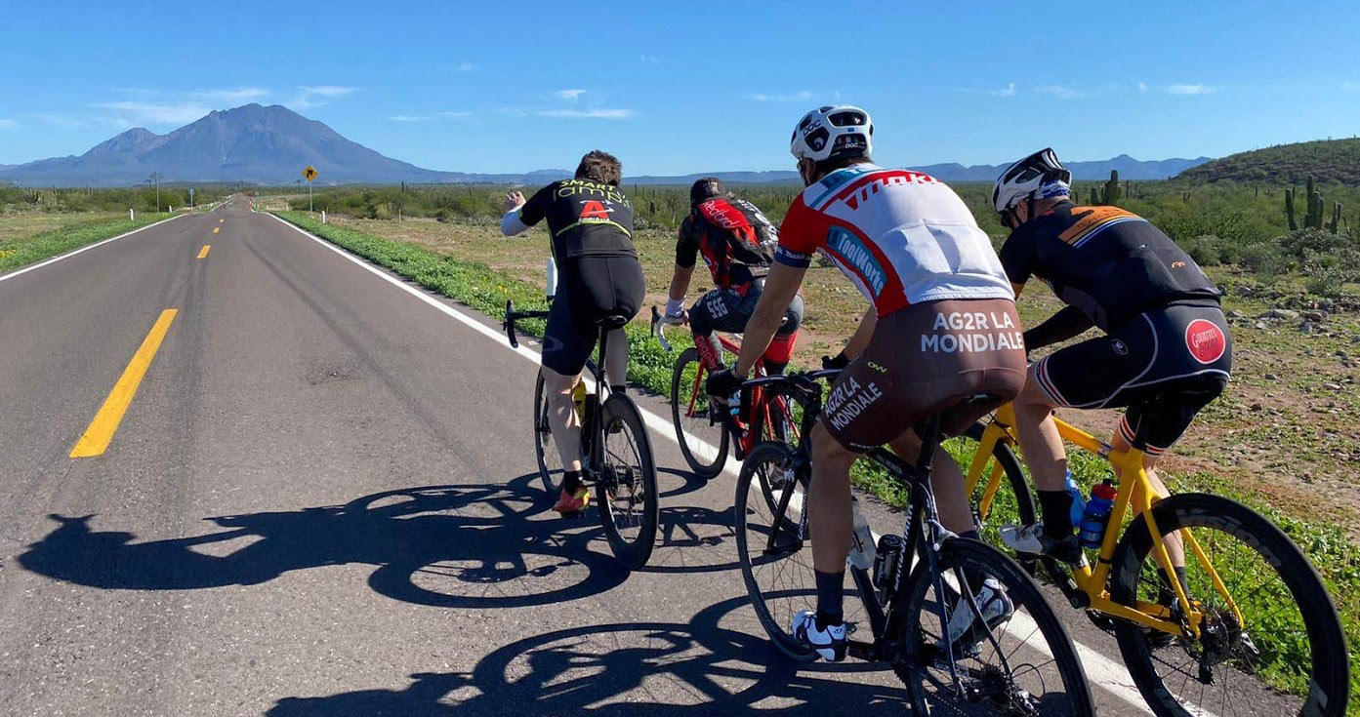
Come join us in Baja to ride the new pavement with patient and polite drivers through expansive landscapes rivaling Joshua Tree, Moab, Big Sur, and fire-red mesas of Idaho. Towering cactus spread across valleys as far as the eye can see, as miles roll by under warm, bright blue skies. Indeed, what is most striking about Baja is this tranquility of wide open space making it the ultimate Covid-era escape: almost 3/4 of Baja’s 3.3 million residents live near the border cities of Tijuana and Ensenada. The rest of the 55,366-square-mile peninsula—is wide-open space, an increasing amount of which has and is becoming preserved as federal and private nature and marine reserves.

Why Baja? There are three things that make a great bike trip: beautiful rides, friendly locals, and good grub. Baja delivers on all of these, in spades - with a bonus of warm sunny weather and clear skies. With travel restrictions and uncertainty to popular places in Europe and Asia, come enjoy equally fabulous and kind people, great cuisine, and pleasant riding. Over the last 25 years we’ve experienced how fleeting these off-the-radar places are, often disappearing within a short window of time. Things too are changing quickly in Baja with new hotels and expanding towns, but for now come ride easy peaceful miles on tranquilo roads, enjoying the peninsula’s sublime rugged beauty. Ride it now before you miss out on another place when it was most special.
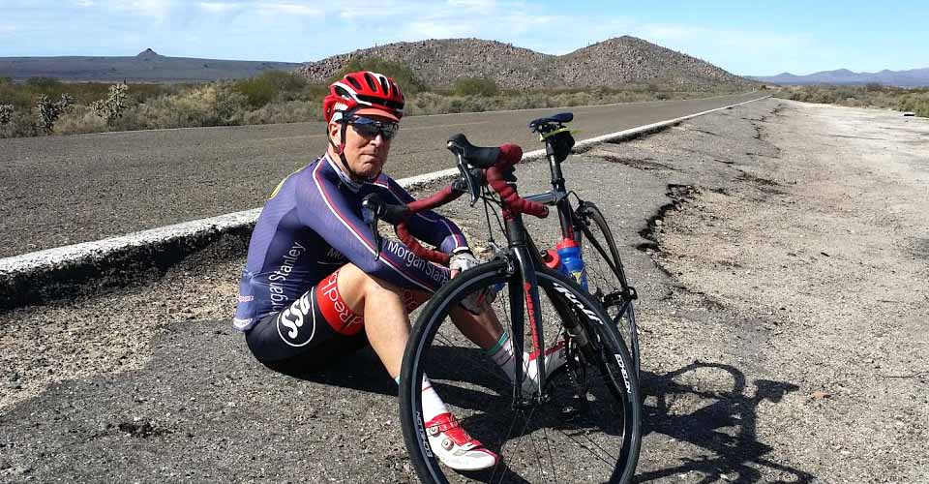
After crisscrossing the peninsula the last few years, no one knows these roads better. Our journey travels the length of Baja, riding through the bourgeoning Guadalupe wine region, through nature preserves of towering-cactus, palm-fringed oases, small rustic towns, historic missions, high-desert mesas, jagged coastal cliffs, marine national parks and islands.
Note: Built-in distancing: for travel with the uncertainty of Cornavirus, Baja is a close destination with easy and frequent connections home, and a place populated with few people – ideal for a close and safe getaway with a familiar culture.
—VeloPura

TRIP AT A GLANCE
ITINERARY  Day 1: Arrive Tijuana  Day 2: Tecate to Guadalupe  Day 3: Guadalupe to San Quintin  Day 4: San Quintan to Cataviña  Day 5: Cataviña to San Ignacio  Day 6: San Ignacio to Mulegé  Day 7: Mulegé to Loreto  Day 8: Loreto to La Paz  Day 9: Departure by La Paz or Cabo | DATES & PRICES  1/ February 4 to 11  2/ February 21 to 38  3/ March 4-10, 2021 FULL  4/ March 17-24  8 days / 7 nights  Per Person pricing from  $4,680  REQUEST MORE INFO (see below)  ARRANGE A PRIVATE TRIP (see below)
TOUR HIGHLIGHTS  - Travel the length of Baja’s 1,000 miles of largely uninhabited canyons and valleys, rugged coastline, mesas, nature preserves, and cactus desert.  - Explore the ever-popular Guadalupe Wine Valley with wine tasting  - Ride newly-paved roads with little traffic  - Visit Baja’s historic missions and towns  - Stay in Loreto and La Paz, two of Mexico’s most picturesque small towns  - Feast on traditional Baja and Mexican cuisine  - Enjoy Warm sunny weather, everyday  - Stay on to enjoy whale watching and other activities on the Baja coast | Why JOIN this tRIP  - One of the best and newest cycling experiences in the world  - Handpicked finest hotels and restaurant  - Limited to 10 travelers  - Experienced pro & local guides  - 100% guaranteed departures  - Fully-supported trip  - Emergency air evacuation included  - Close - Wine, warm people, great cuisine like Italy, but without the longer travel  - * The ultimate social-distancing destination * Baja is remote and sparsely populated *
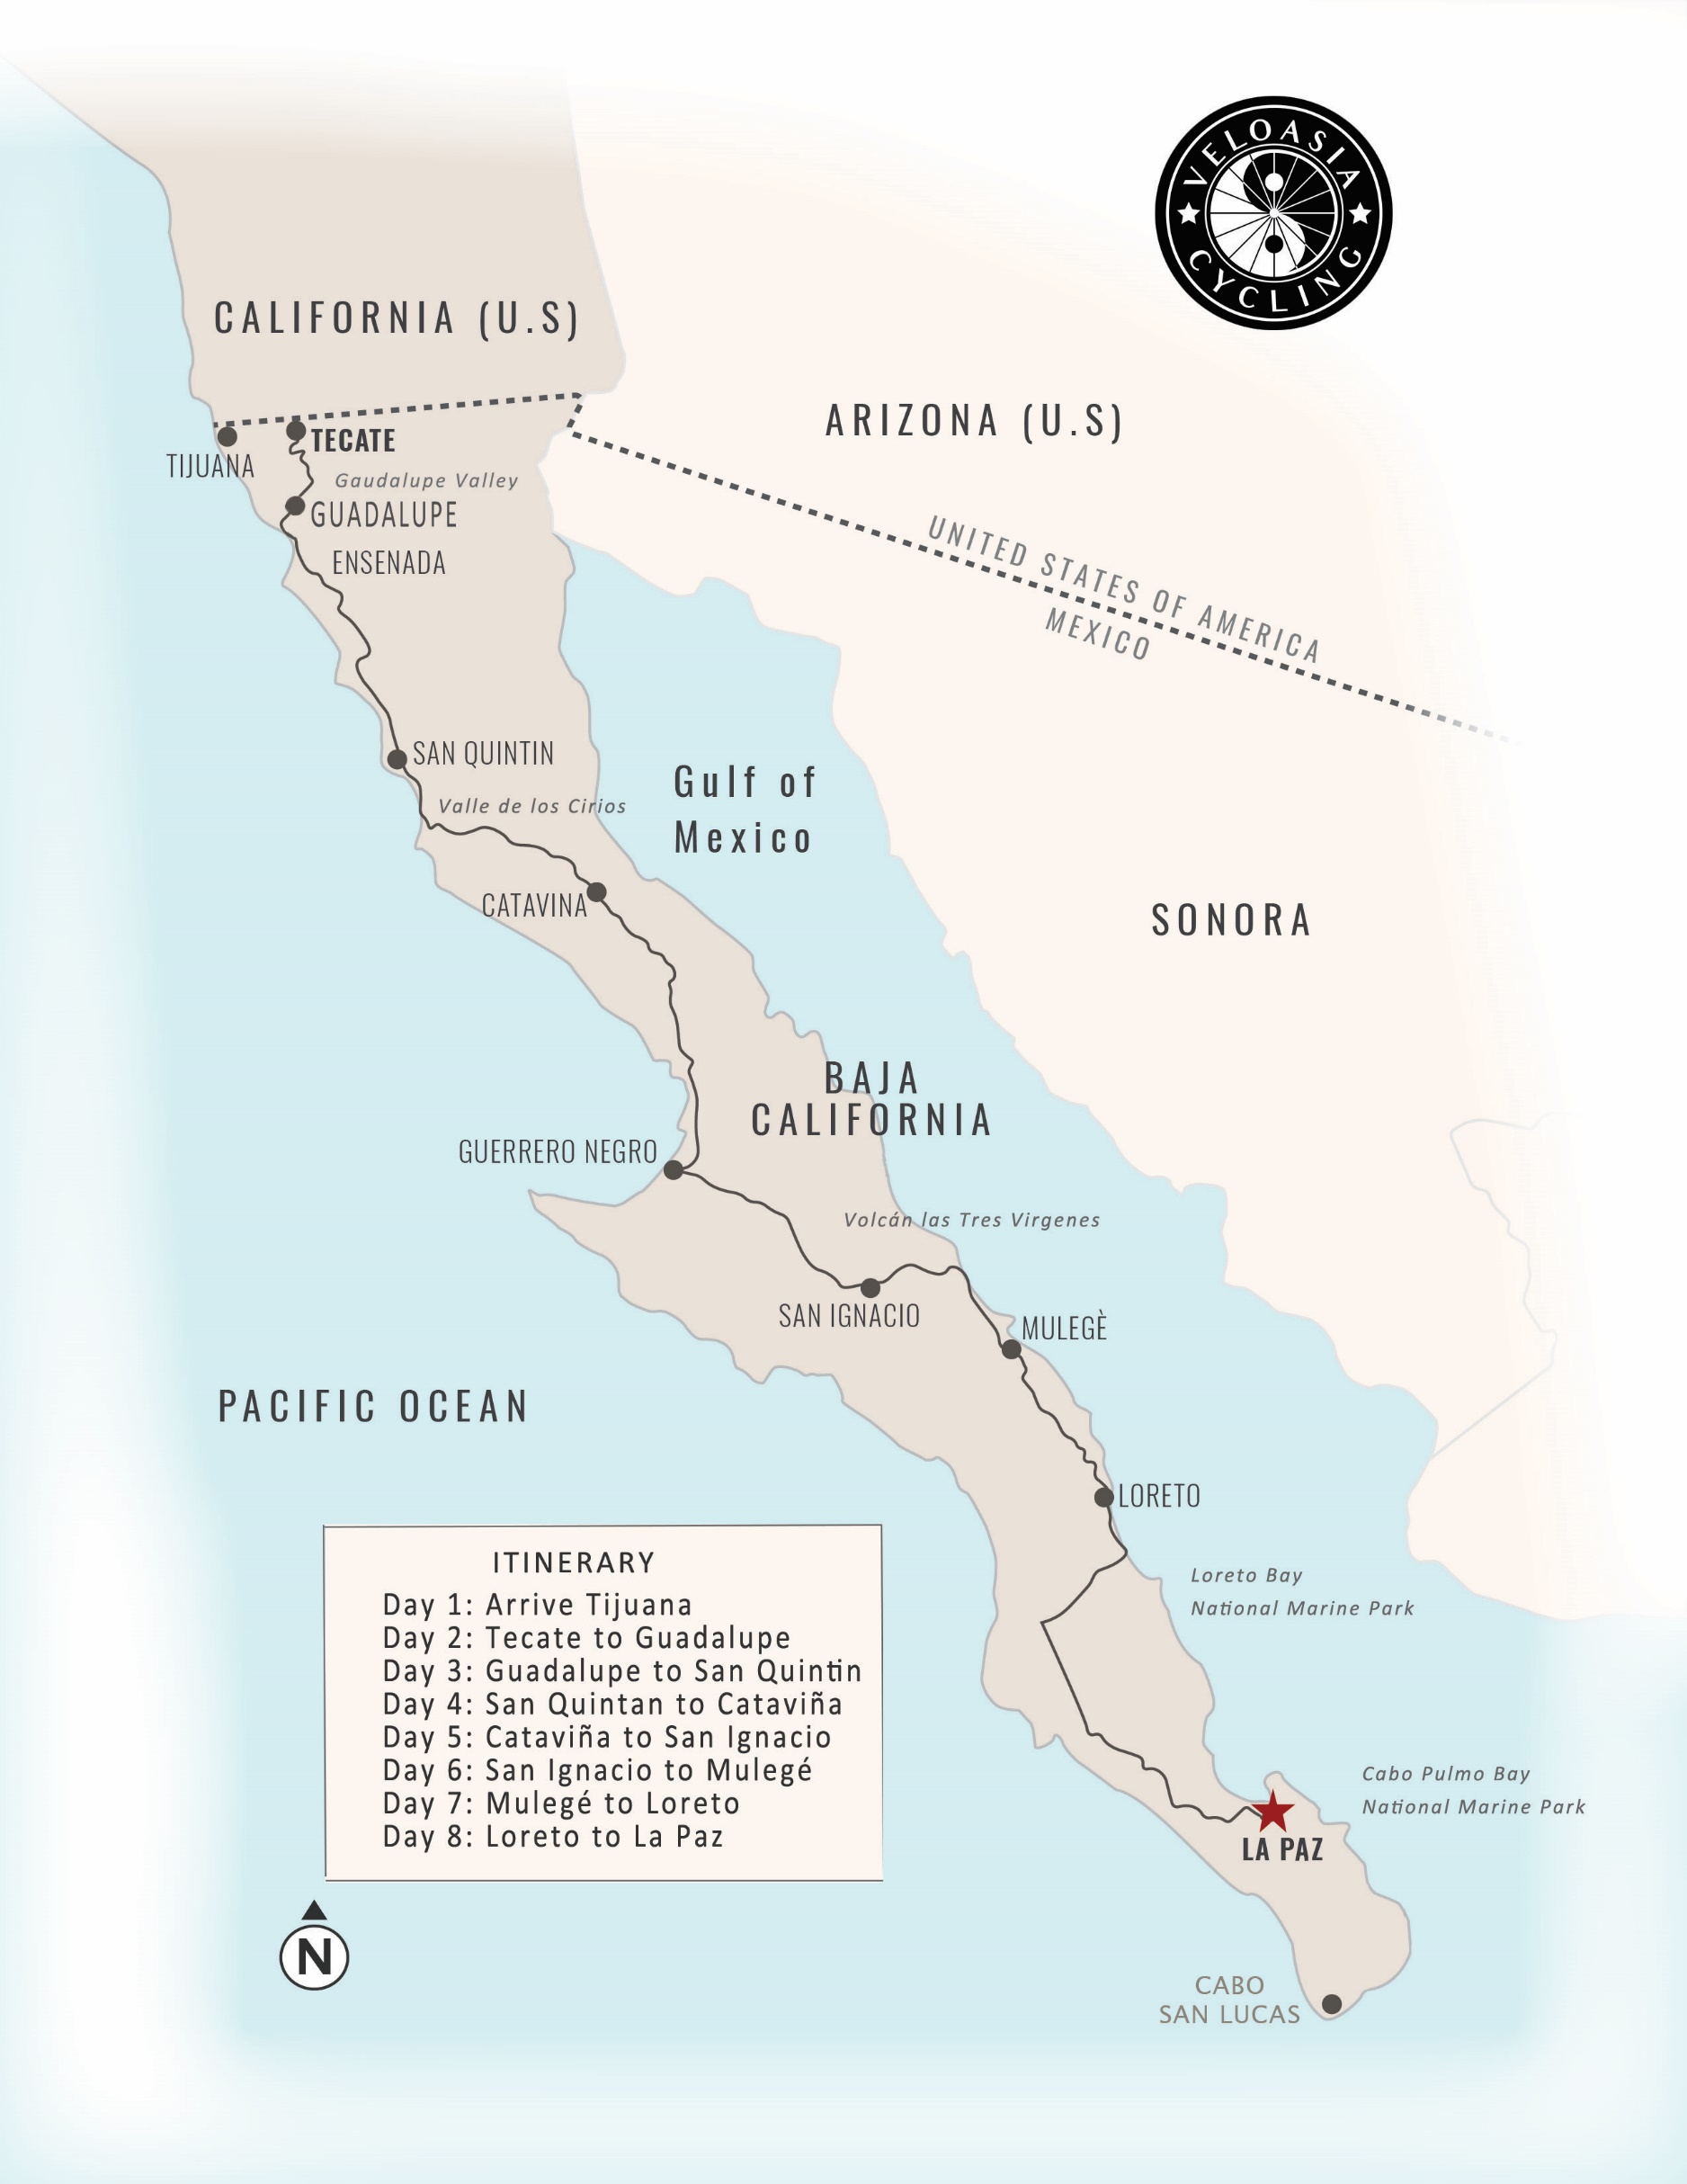

día 1:Tijuana
Arrive and meet your driver for transport into town to our hotel. After introductions, we’ll unpack and assist building your bike up for testing on a short ride. Long known as a rundown party mecca, sprawling Tijuana has undergone massive redevelopment in the last few years, with a pleasant central promenade, stylish hotels, and upscale dining. In 2017, Tijuana was named one of the The New York Times’ top travel destinations.
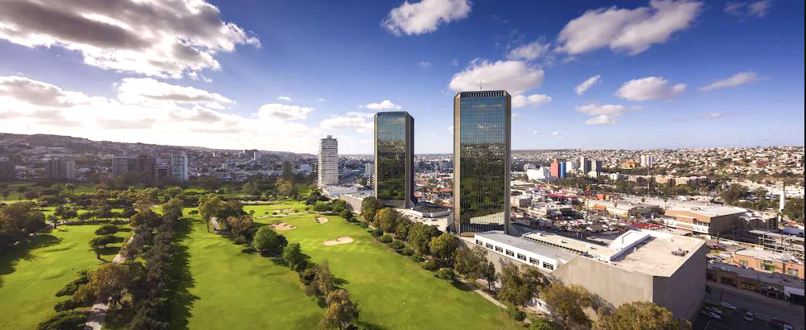
As a culinary destination, Tijuana is famous for its street food, especially mariscos, birria and tacos of all stripes, which we will sample during our downtown stroll. Tonight, we’ll enjoy a special dinner and wine tasting planned by chef owner Javier Plascencia at his elegant cocina de Baja, Mision 19. Javier is one of a the a new breed of natives driving Tijuana’s revitalization. Read more about his efforts in the New York Time’s Master of a New Tijuana.
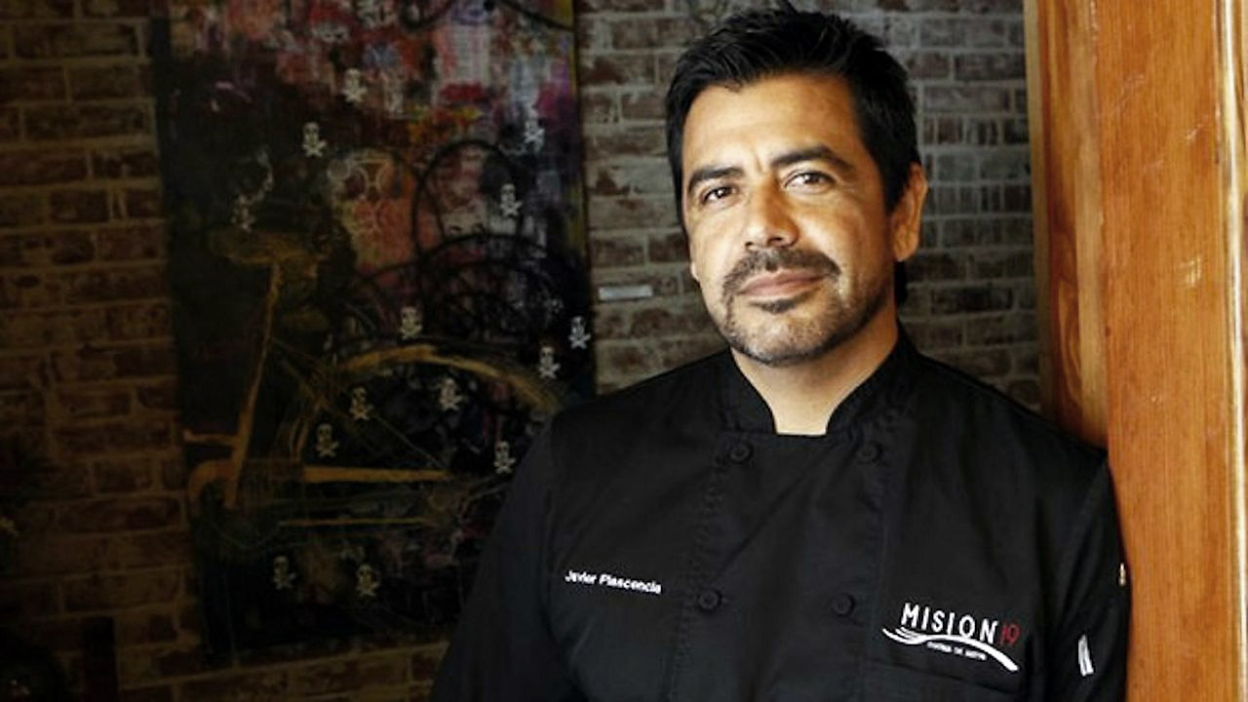

día 2: Tecate to Guadalupe 51 MILES +3,227 FEET
RUTA VINO - GUADALUPE WINE COUNTRY
Today we ride the classic Tecate to Ensenada route, but on a new highway with wide shoulders and gentler grades. Our ride meanders through green countryside, few small towns, and finally, through the vineyards of the Valle de Guadalupe, Mexico’s fast growing wine region. After arrival, we’ll enjoy lunch in a local winery and spend the afternoon visiting other local wineries. Our driver, Ivan lives here and leads trips in the valley. After, we’ll enjoy an swim, dinner featuring regional specialties, and overnight in a villa overlooking the valley.
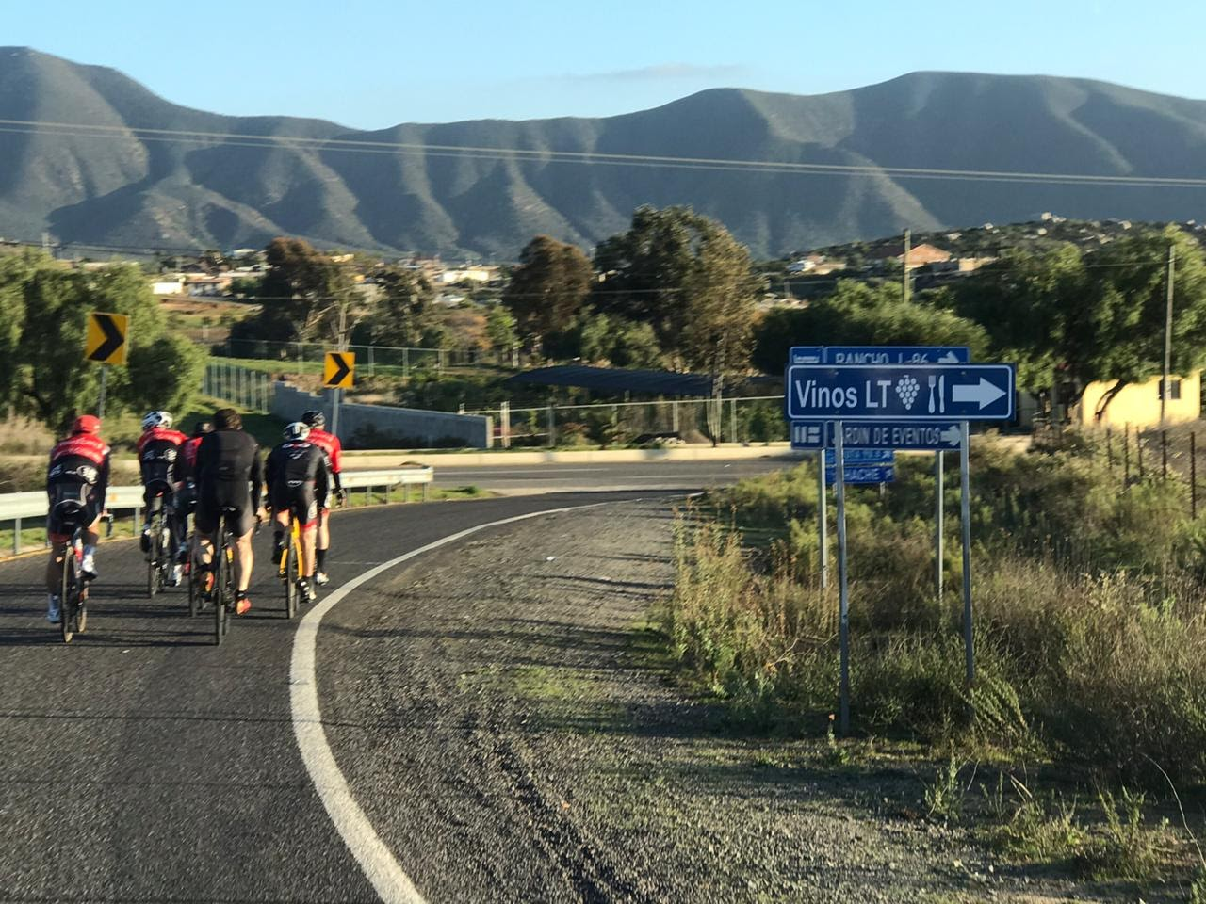
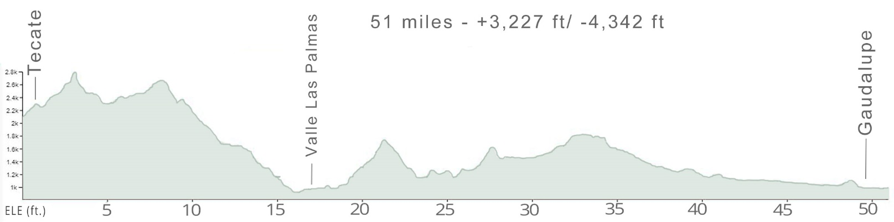

día 3: GAUDALUPE to Puenta Colonet 50 MILES +3,114FEET
LAGARS AND GRANJAS
After a delicious breakfast of fresh flour tortillas, huevos, queso, chilis, frijoles and fruit, we’ll shuttle up the road for our day start in the verdant mountains under expansive skies of Baja, rolling along the green pastures, small farms and vineyards. As we crest hills, the empty landscapes open up and we’ll enjoy breathtaking views over the expansive valleys, rugged canyons, and scrub arroyos. In the afternoon, we reach our secluded beach resort with time to enjoy a walk on the sand before a dinner banquet featuring more fine vinos de Guadalupe.
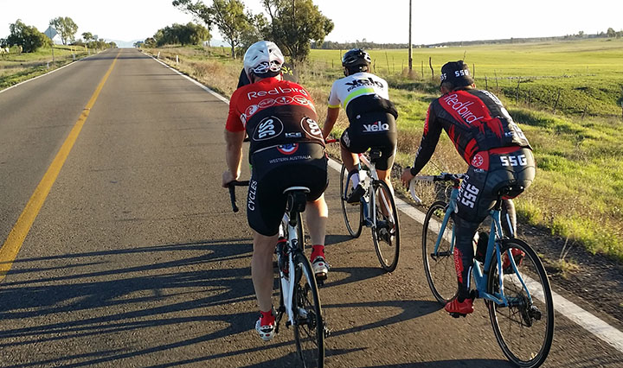

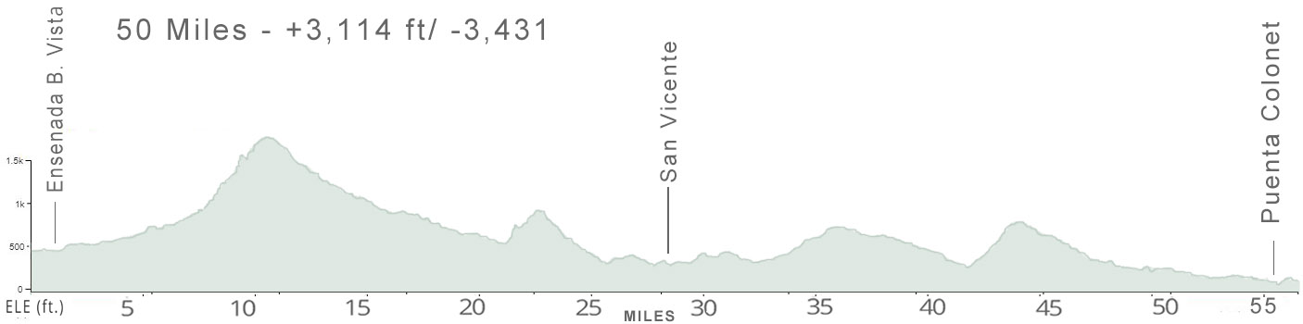

Día 4: San Quintín to Cataviña 75 MILES +4,234 FEET
Valle de los Cirios
This morning, as the sunrises over the waves, we’ll ride along the coast before climbing into the magnificent Valle de los Cirios nature preserve, a massive protected region with stunning landscapes resembling Joshua Tree with towering sienna-colored mesas. Along this desolate road without any towns and little traffic we’ll marvel at our first glimpse of thousands of towering Cardón or Elephant Cactus, the world’s largest cactus, which can reach up to 65 feet high, as well as boojum, yucca, and elephant trees, and wild ocotillos as far as the eye can see. As we climb up onto the plateau, the wild landscapes seem one vast expanse under bright blues skies, and the only sounds are light breezes.
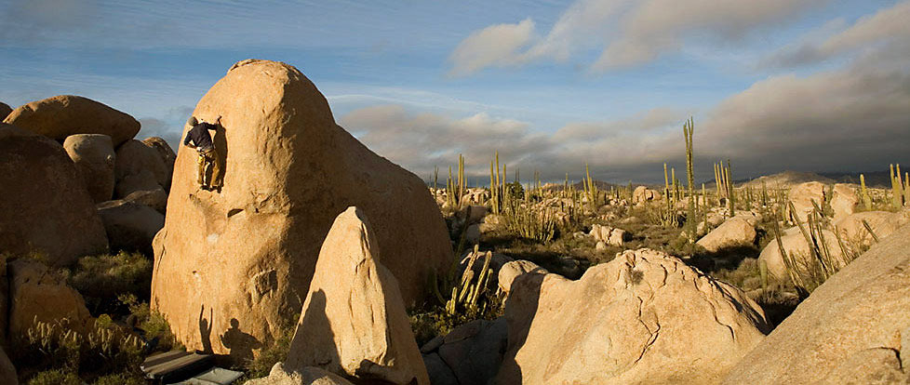
As we near our destination, a remote tranquilo outpost situated upon an oasis, Cataviña, a vast plain of giant rock boulders appears, an area that is popular with eco-tourists and rock climbers. Today is our longest ride and there will be cold cervezas by the pool after we arrive.
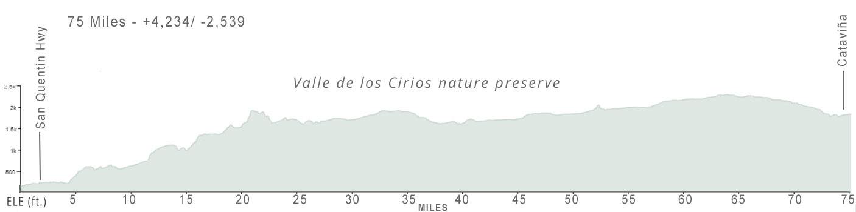

día 5: Cataviña TO SAN IGNACIO 68 miLES +1,397 ft
THE CACTUS PLATEAU
If you're awake early, we’ll have a short hike before breakfast, watching the sun rise over the boulder plain as the colors change on the massive rocks in the morning light. All around our route today is the bed of ancient ocean, now dotted with cactus and other desert plants as far as you can see. This day captures the wonderful solitude of Baja, with only a single town during the flattest ride of our trip over newer pavement.
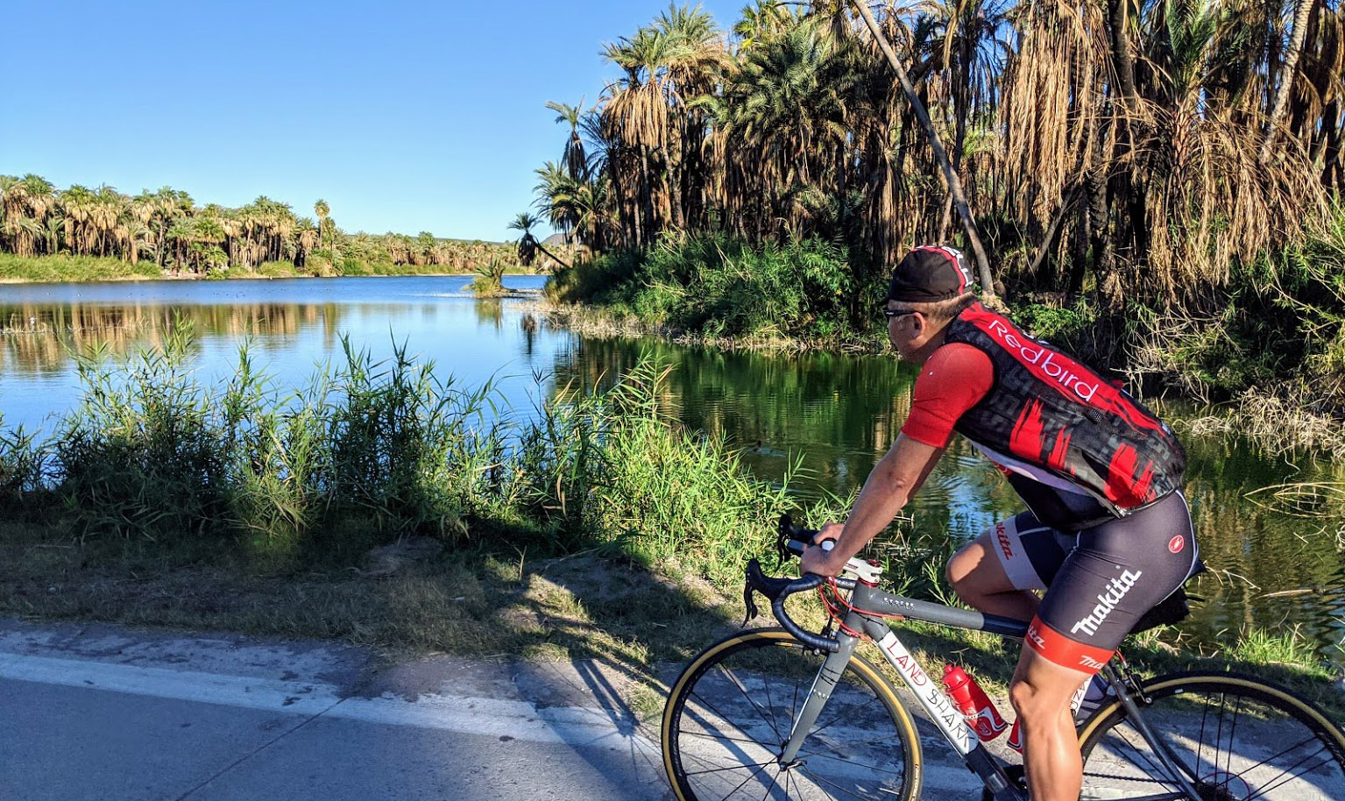
After stopping and loading up, we’ll van to Guerrero Negro for a lunch of delicious fresh local lobster and seafood before crossing into Baja Sur (south) and on to San Ignacio, location of an early mission with a small colonial-era plaza with an impressive well-preserved church.

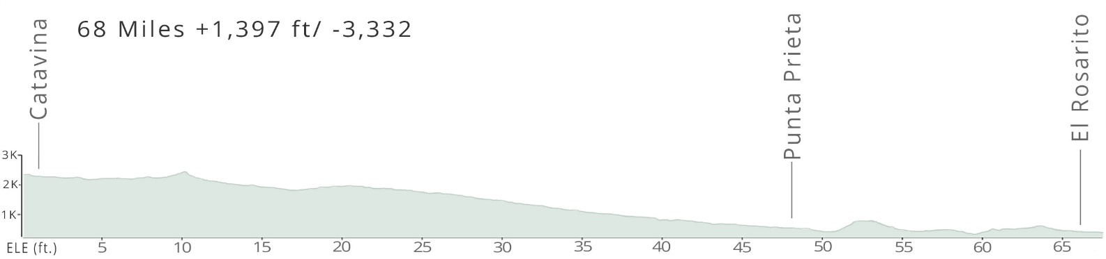

día 6: SAN IGNACIO TO Mulegé 46 miLES +2,159 ft
ACROSS THE DIVIDE
Sprawling canyons spread over the landscape, as we gradually climb, rewarded at the summit with incredible views of a massive valley of organ pipe and golden barrel cactus. As we descend, suddenly there is a cools breeze as the blue waters of the Sea of Cortez appear.
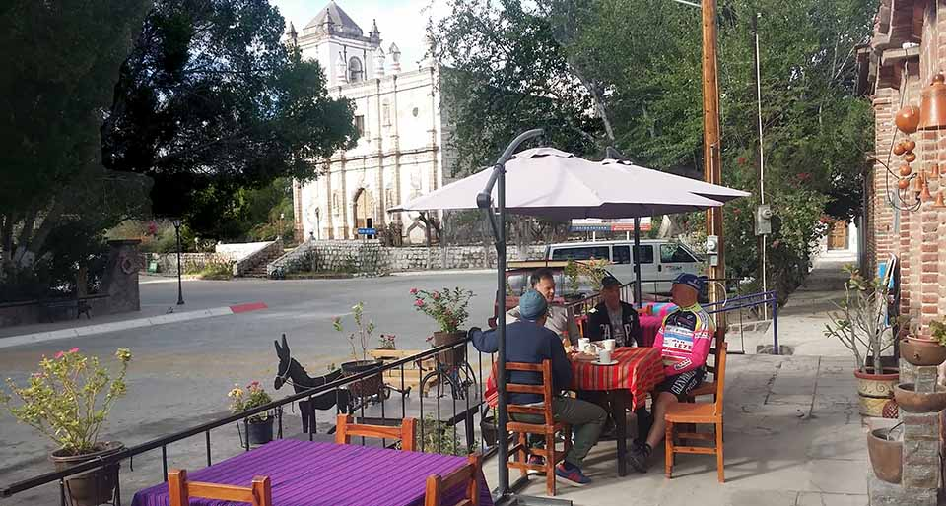
After reaching the coast, we’ll lunch along the coast before reaching the small oasis town of Mulegé, at the mouth of Río de Santa Rosalía. Settled by Jesuits in the mid-1700s it was location of the first mission in Baja. Recently, it has become a bohemian enclave of artists.
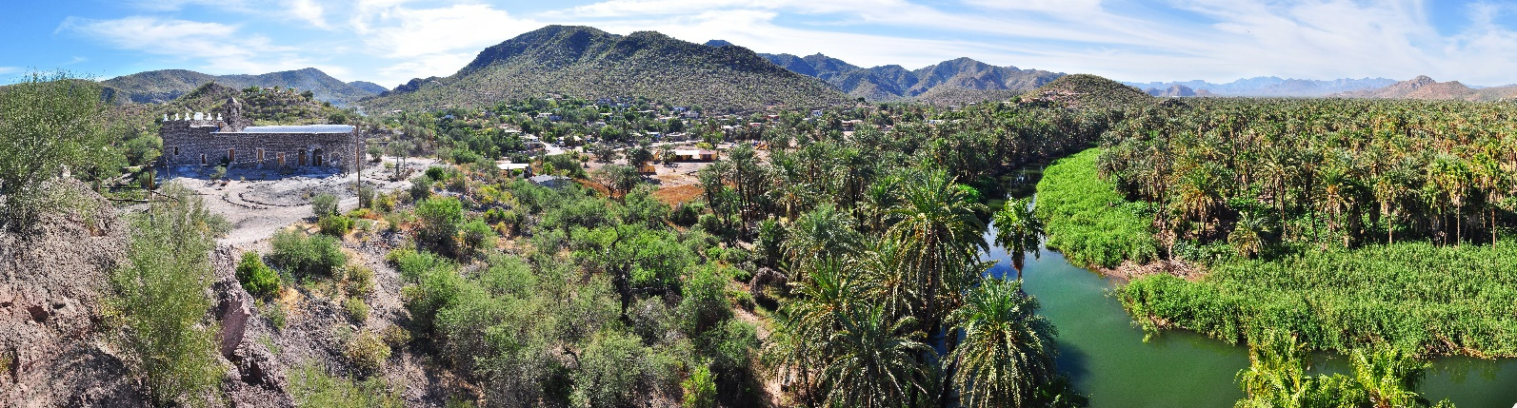
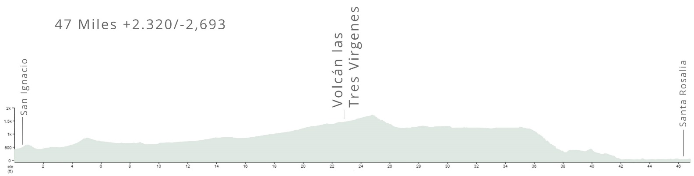

día 7: Mulegé to LORETO 84 miLES +2,687 ft
BEACH COVES AND ARROYOS
Today’s ride out of Mulegé, rolling along the coast, is the most spectacular of the trip. We meander along the cliffs along postcard-perfect beach coves and lagoons with bright red cliffs rising dramatically on the inland side. Midway through our ride, we pass through rolling desert plains passing arroyos and pequeño pueblos. At ride’s end, we roll into Loreto, which has just renovated it’s central district in 2020 and has a distinct local flavor.
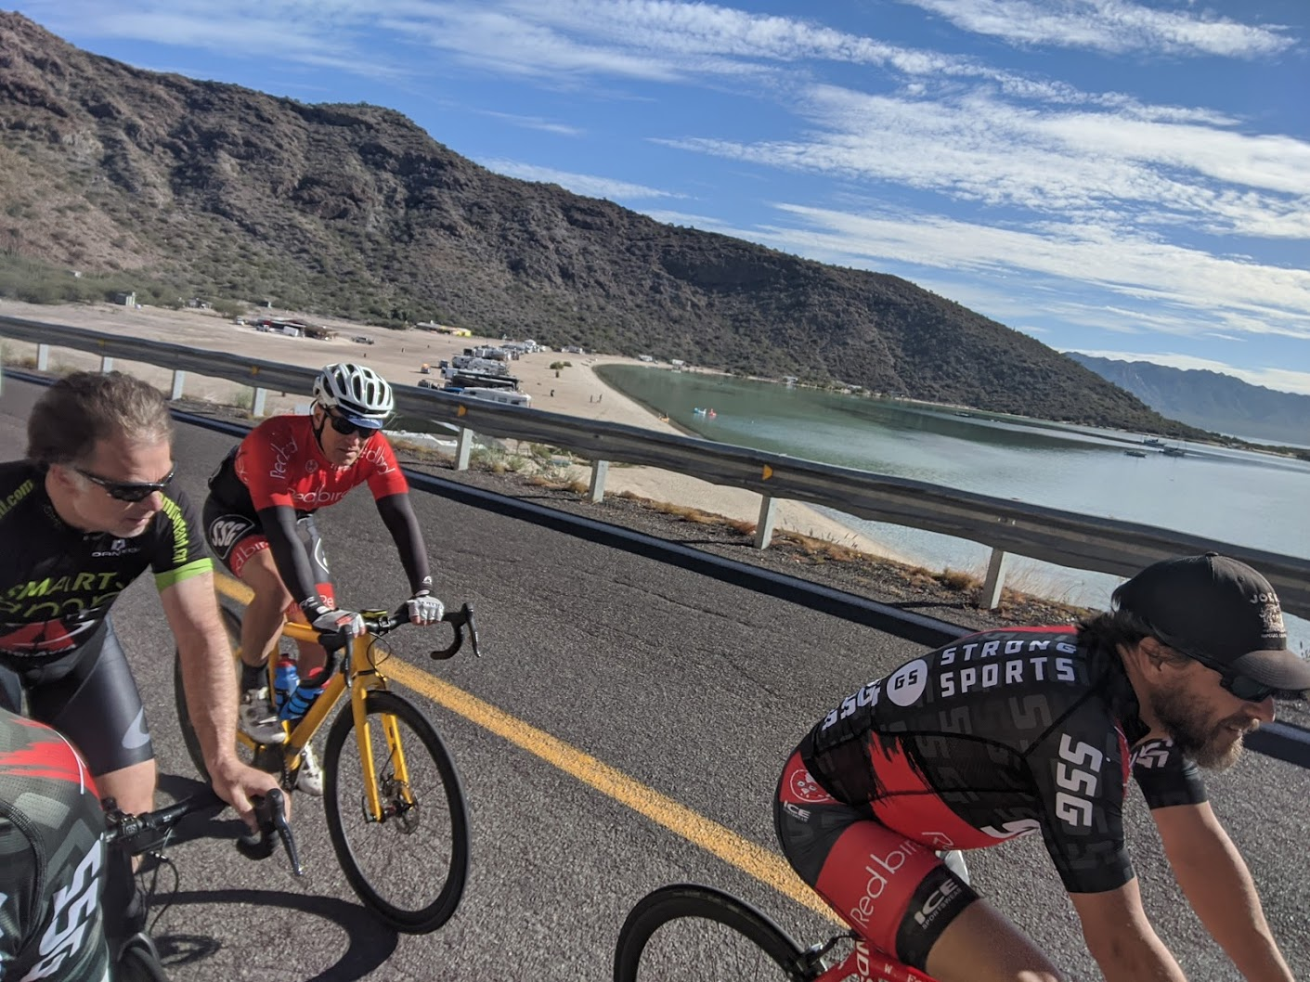
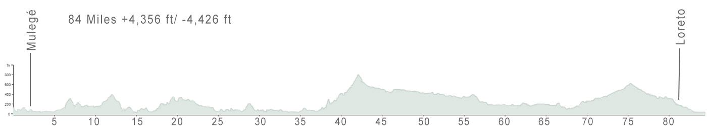

día 8: LORETO to LA PAZ 48 miLES +2,205 ft
THE LORETO BAY
After another delicious Mexican breakfast, we’ll ride along the coast with sublime views of the Loreto Bay National Marine Park dotted with islands with a mix of stunning cliffs, wide sandy beaches and rock formations.
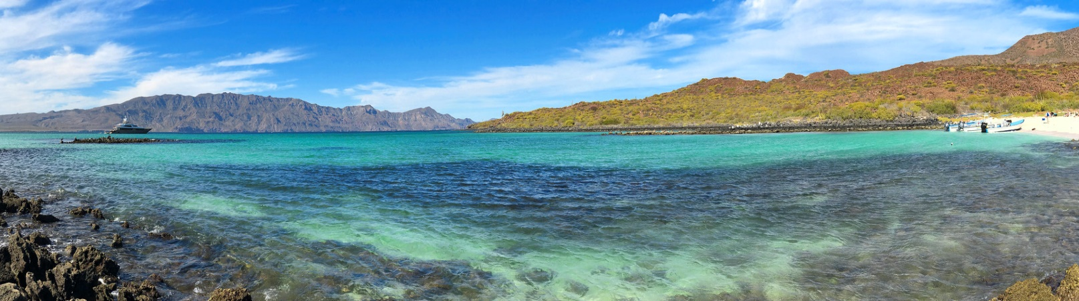
One the longest climbs of our trip appears as we turn inland, but it’s a gentle grade of only two and half miles, followed by stunning canyon landscapes of red and green. In the afternoon, we reach the one of the most pleasant towns in Mexico, La Paz.
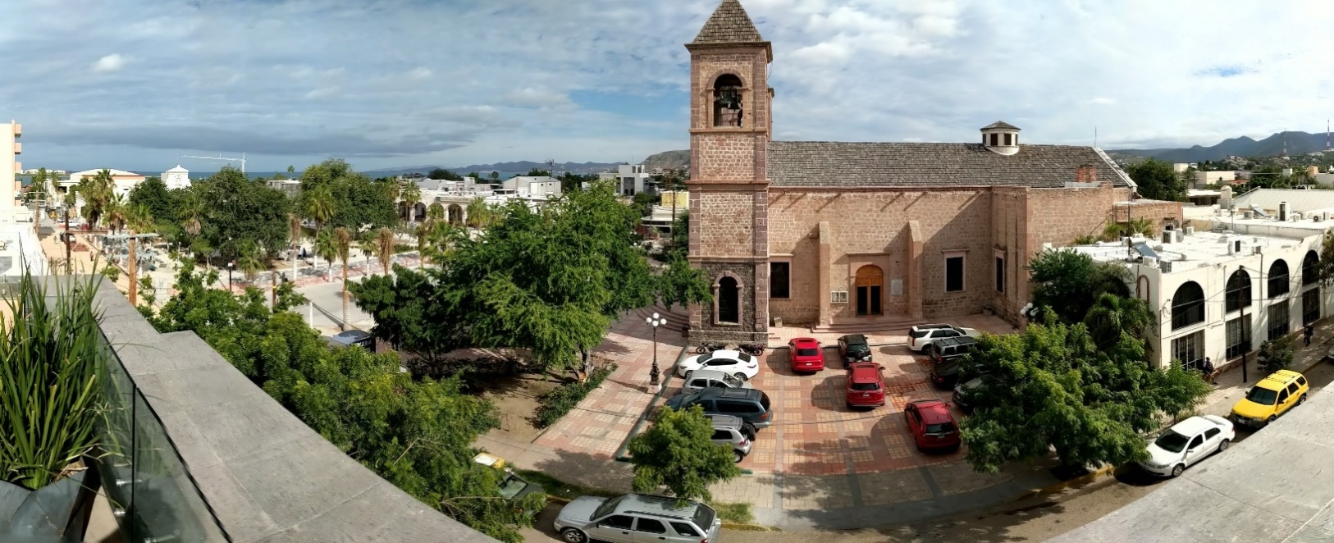
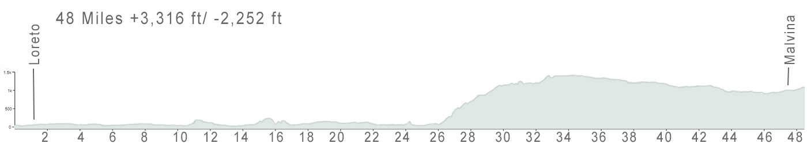

DEPARTURE
HASTA LUEGO
Stay on longer for well-deserved R&R in nearby San Jose del Cabo, or whale watching, sport fishing, sailing, cooking classes, yoga, wind surfing, snorkeling (Jacques Cousteau famously called the Sea of Cortez, home to some 800 varieties of fish, “the world’s aquarium”), mountain biking, or visiting nearby towns, such as the vibrant artist town of Todos Santos.
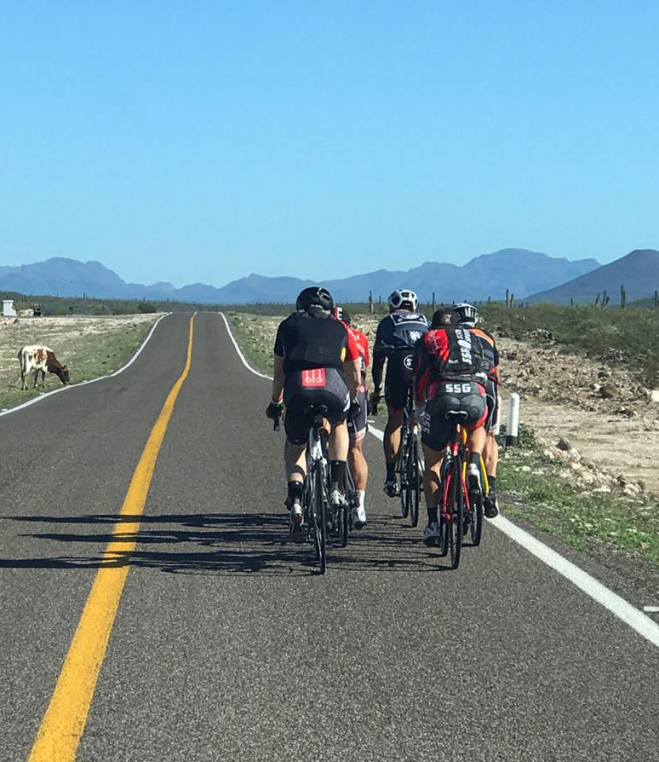

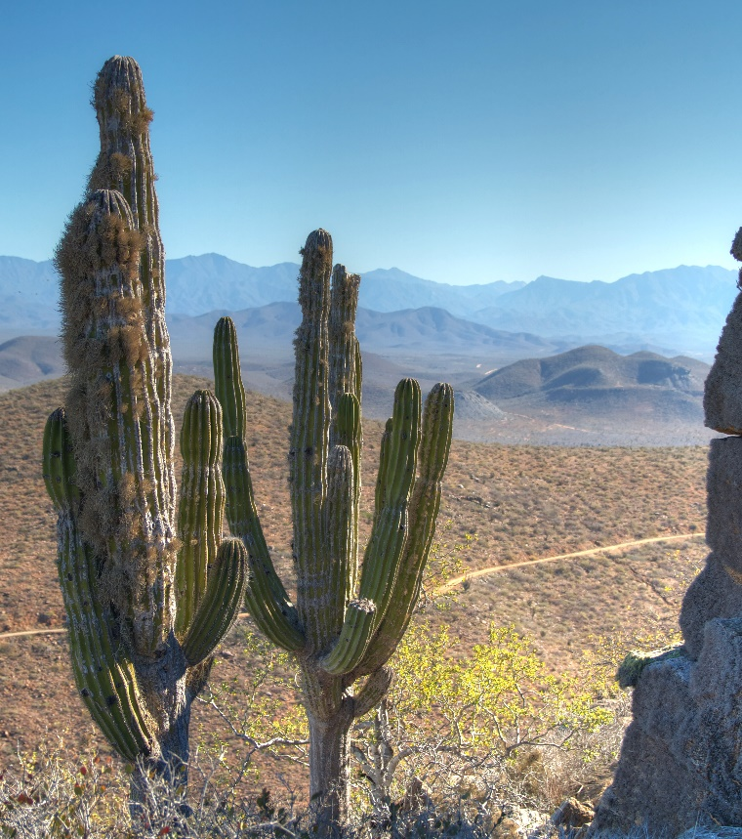 | 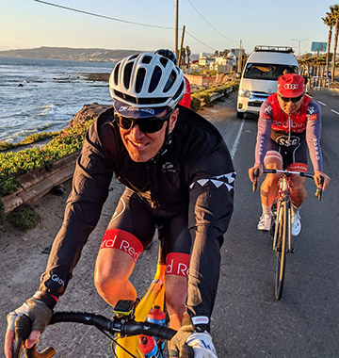
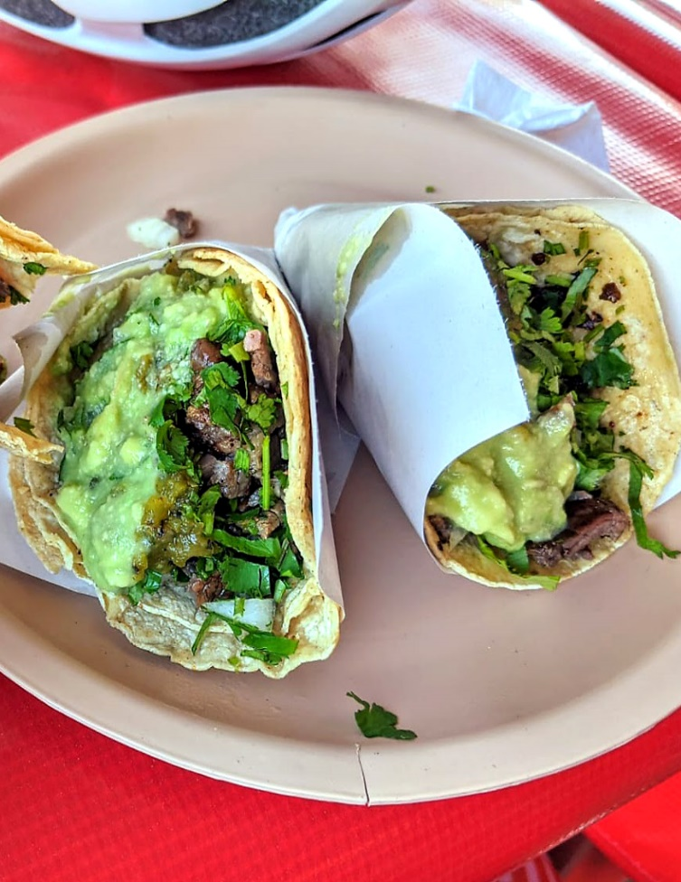 | 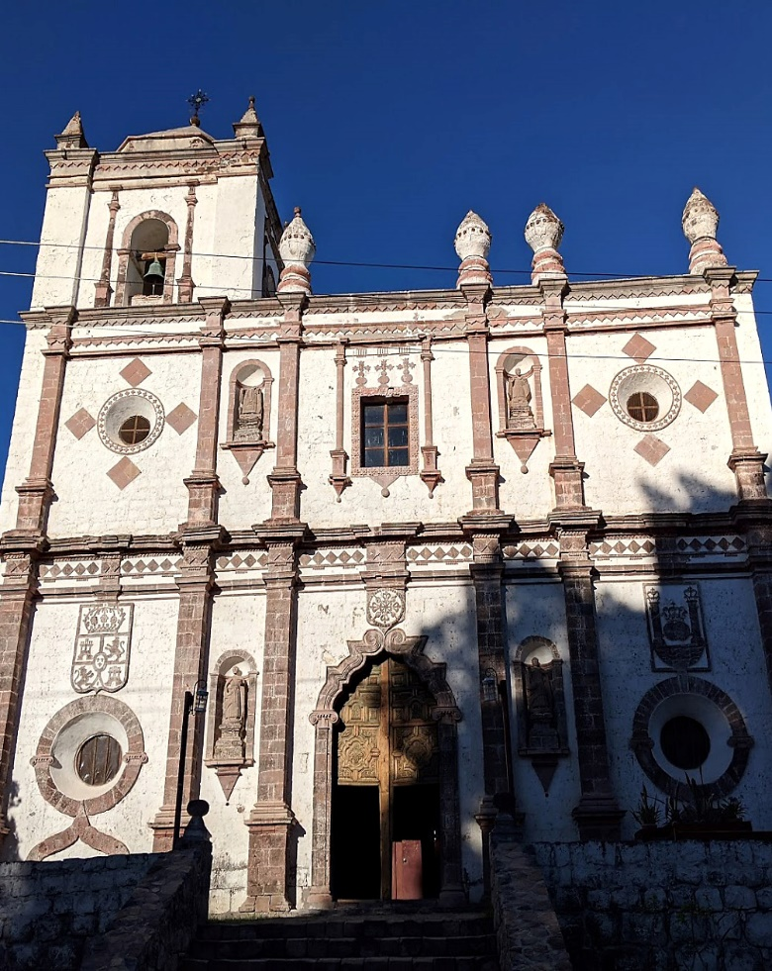

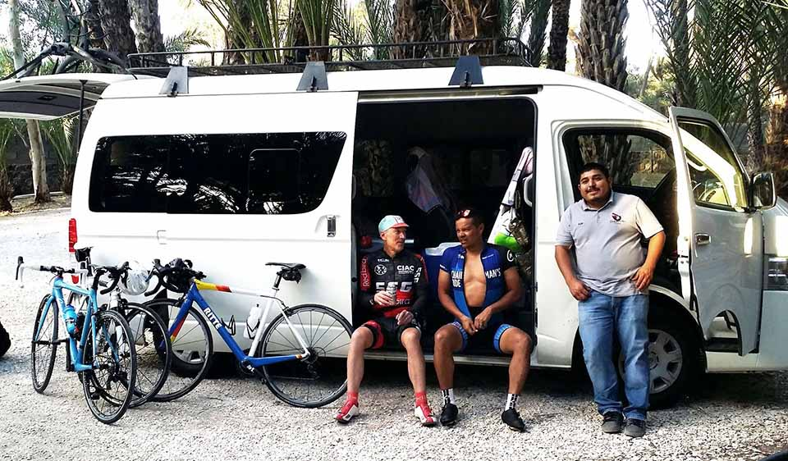

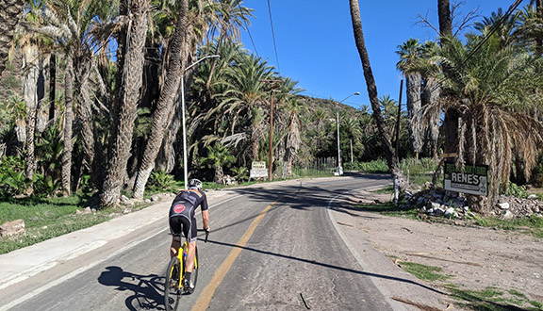

THE DETAILS
2021 will mark our 3rd season of cycling Baja, during which we’ve refined the trip to the best biking routes, places to stay, eating, and training of a world-class support crew with over 20 years’ experience leading trips. This eight-day journey is fully-supported. Riders can expect beautiful, safe rides, plenty of delicious Mexican grub, hot showers, and cultural activities on the side. This 8-day trip is limited to 10 riders. This trip may be organized as a private, custom tour for you and your friends or family. For more information about this trip, please see: www.veloasia.com/baja.html

PRE-DEPARTURE
In addition to a pre-tour preparation packet for Baja, all riders are welcome to contact us in advance of the trip, for questions and information they may need.

ARRIVAL & DEPARTURE
Please contact us before arranging your flights for recommendations, and even for booking a ticket. If you are flying in, you’ll want to arrive into San Diego or Tijuana Airports, with departure from Cabo San Lucas. For a moderate additional cost, we will arrange transport from the airport in San Diego for you to join us in Tijuana, including a stop to obtain your visa at the border.

DAY-TO-DAY
Our Baja trips are designed for moderate to advanced riders comfortable riding 2-5 hours at a steady pace, though all riding is optional—our Sag wagon is always nearby, even for a catching a quick lift up the longer climbs. We typically ride as a group, though faster riders may ride ahead if desired or add additional mileage. We typically depart mid-morning around 9 AM each day, with a break for a pleasant lunch. Afternoons after arrival with include some time free, or we will have scheduled sightseeing, such as visiting the historical Jesuit missions along our route. Mornings before we depart also provides some time to see local sights.

WEATHER
The weather in Baja during our touring season is always sunny and warm, no rainfall, and typically reaching into the 70s to 80s midday. Evenings are pleasantly cool, but not cold.

BIKES & BIKE RENTALS
We always recommend you bring your own bike. Airlines have become more adept with handling bikes, and also have sharply reduced charges. We will assist with transport of your bike from and to airports, assembly, maintenance, disassembly and packing up. Contact us if you are interested in renting a bike for available models in your size. Our support van and your guides will have all necessary tools, pumps, tubes, tires and other essentials to keep you rolling.

HOTELS
In places where there are choices, such as Guadalupe and La Paz, we stay at the finest properties available, such as Encuentro overlooking the vast expanses of Valle de Guadalupe (below), while in other places, such as Cataviña, we stay in the only accommodation available, rustic yet comfortable. Contact us for specific hotels by location for the dates of your trip.

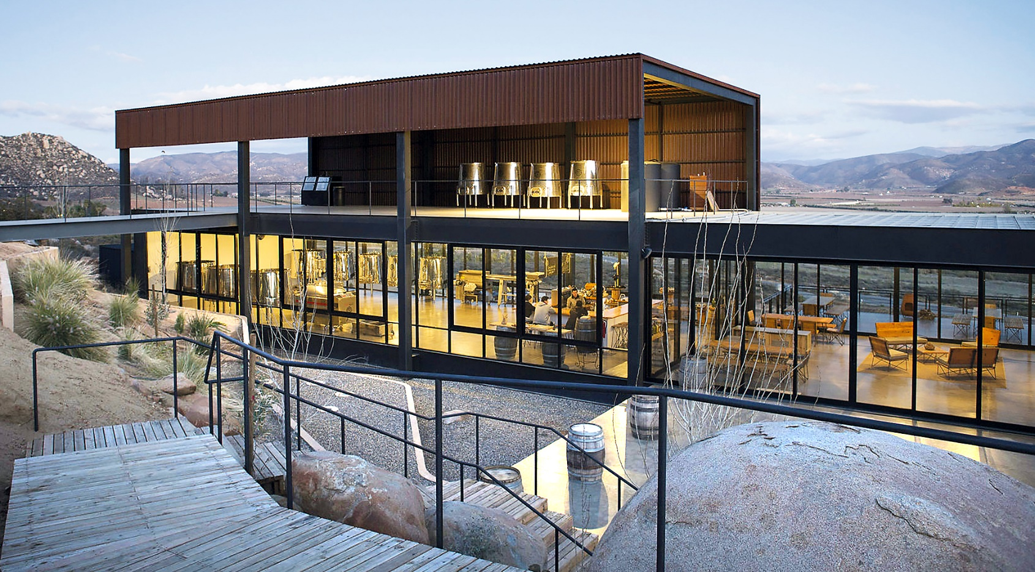
Encuentro Guadalupe

DINING
Our past travelers will tell you our trips are as much as about the food as the riding. In fact, after 20 years our Iron Chef Vietnam culinary cycling trip remains our most popular. Our meals feature a variety of the best of Baja, from the most delicious tacos in the world, fresh seafood, including lobster, grilled and rotisserie meats, sinful chilaquiles, heaping bowls of fresh guacamole with handmade chips always served with piping hot flour tortillas and fresh salsas. Guadalupe-produced vinos are available throughout our route. Our van is stocked with typical rider’s fuel, including carbo mix, bars, bananas and other fruit, but also a variety of cold beverages and local snacks popular in each location.

EMERGENCY & MEDICAL
For expediency, VeloAsia will arrange medical and evacuation coverage for your participation through a local service who is experienced. The cost of this service is included in your trip cost.

Trip Leaders

Victor Ayala
Victor lived and raced at the top level in Los Angeles for over twenty years, much of that for the legendary cycling club La Grange attending stage races throughout the U.S. and Latin America. In recent years, Victor returned to his native Ensenada where he continues to ride and race around his entrepreneurial interests, including founding one of the city’s most popular cafes.

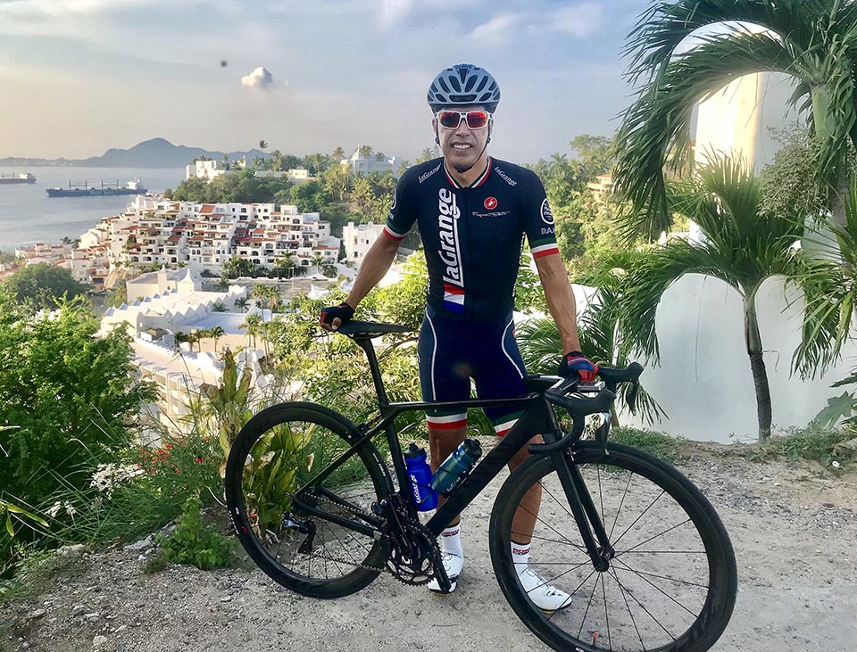

Ivan Tolentino
During the annual tourist season, Ivan leads trips around his hometown, Guadalupe, through the now famous wine route Valle de Guadalupe, which produces most of all of the wine that comes from Mexico. In addition to wine, Ivan is an expert on Mexican tequilas as well as not-to-miss taquerias along our route. Ivan lives in Guadalupe with his wife and two children.

TRIP COST
See page 4 for trip dates and costs. Single rooms are limited, at an additional cost of $1,280.
What’s included
- Emergency medical and evacuation insurance
- Pre-trip packet
- All accommodations, meals, snacks, bottled water
- Technical support and supplies (tools, tubes, tires, cables, etc.)
Not included
- Flight to and from Baja (can be arranged through us)
- Visa ($20, issued upon arrival)
- Bicycle and gear (rental can be arranged)
- Alcoholic beverages
- Expenses of a personal nature
- Airport transfers (we will arrange, extra cost dependent on arrival airport)

PRIVATE CUSTOM TRIPS
Most of our trips are private, organized for groups of friends or families. This trip may be organized as a private tour for you and your friends or family, fully-customized to your group’s preferences, including balance of cycling and off-bike activities and sightseeing, even for non-cyclists who want to accompany the trip yet still be engaged with Baja’s sights, attractions, and people. Contact us for more details about arranging a private custom trip to Baja for your group. Note: hotels are limited and can fill for whale-watching high-season up to a year in advance.

NEXT STEPS?
If you are ready to sign up, or if you have questions about this trip, or our other trips, or questions in general, please give us a call at (415) 680-3788 between 8:00 a.m. to 5:00 p.m. (Pacific Time) or send an email to veloasia@gmail.com. To secure your spot on this trip, submit a non-refundable deposit of $1,000 per person. Once we receive your deposit, we’ll contact you about arrival and departure information and other details, and send you a pre-trip packet to you containing detailed information about the Baja trip. This trip may also be arranged as a private, custom tour for you and your friends or family. Register for this trip at velopura.com

ABOUT
Since 1993, VeloAsia has organized bike tours to the most exciting cycling destinations in the world, including Vietnam, Laos, Cambodia, Turkey, Myanmar, Sumatra, Albania, Bhutan, Chiapas, China, and more. See more about this and other trips at www.velopura.com.

